Creating a Basic Mobile First Web 3D App

**Table of Contents**

Introduction 2

Review Week 1 to Week 3 Results 3

Creating the Basic 3D App 4

Develop your Lab 4 basic 3D App 4

Create the new fluid grid layout — Summary Steps 5

Create the new fluid grid layout — the detail 5

Consider the 3D Contents layout 18

Consider the camera buttons panel 20

Add the X3D Model 25

Interaction 3D Buttons 33

JavaScript code for 3D model Interaction 33

3D Image Gallery 34

Complete the HTML5 and CSS3 for coke.html 35

Create the Sprite and Dr Pepper pages 41

Add some About and Contact Contents 41

Lab 5 — Interactivity with JavaScript and PHP 43

Appendix 44

Appendix 2 — Previous Lab Results 44

Week 1 Results 44

Week 2 Results 44

Week 3 Results 47

Appendix 2 — Plugins for 3D Apps 50

Appendix 3 — Steps to Create your Basic 3D App 52

Appendix 4 — Connecting buttons to X3D code via JavaScript in X3DOM 54

# Introduction

This Lab 4 focuses on creating a basic responsive and mobile web 3D application (3D App) by bringing together the previous laboratory results (week 1 to 3) and re-enforcing the knowledge gained so far by:

1. Continuing your investigation into X3DOM (X3D + HTML5) from Lab 3 as a method for embedding or integrating your 3D models directly into the HTML document object model (DOM). You should have an X3DOM Coke can output created by the instantreality online converter and/or the same using the instantreality aopt cmd line tool. Similarly, for the Sprite bottle and the Dr Pepper cup. Having these models in X3DOM format will eventually allow you to manipulate your model’s X3D nodes (via JavaScript) in the HTML5 web page.
   * JavaScript will be investigated in Lab 5 and 6 in this respect
2. Gathering up all your results from Week 1 to 3 into a basic responsive 3D App (i.e. a responsive and mobile first Web 3D application)
   * This will involve refining your Lab 1 fluid grid template somewhat. In this respect, it is worth reinforcing the notion of keeping an eye on your libraries. For example, in week 1 we used the Bootstrap 4.3 libraries. I have now noted that the latest version is now 4.4. We might switch to Bootstrap 4.4, but sometimes when doing this something fundamental doesn’t work, if so we will switch back to Boostrap 4.3.
   * Thus, one of the first things you need to do is change your Bootstrap library to Bootstrap 4.4, either by install such, or using the BootstrapCDN as a quick test first.

# Review Week 1 to Week 3 Results

You should have 3 keys sets of results from the previous 3 laboratories. You can see in Appendix 2 — Previous Lab Results what your results should look like. If you have not finished these or achieved these results you need to correct or catch up. The [**Live Feedback Site**](http://users.sussex.ac.uk/~martinwh/3dapp/3dapp/labs/) located at (<http://users.sussex.ac.uk/~martinwh/3dapp/3dapp/labs/>) also gives you the correct results and codes so that you can compare and contrast.

# Creating the Basic 3D App

It is possible, but becoming increasingly harder to integrate plugins to render 3D in a web browser, thus largely making plugins a non-viable technology for a good 3D App. Appendix 2 — Plugins for 3D Apps on the Web discusses this is more detail, suffice to say we will not be using 3D plugins in your 3D App. However, we will use a couple of 3D tools (including one plugin) to test our VRML after exporting from 3ds Max to make sure it works before conversion to X3D.

## Develop your Lab 4 basic 3D App

We will now develop our Bootstrap based Lab 4 basic 3D App based on your Lab 1 template, for example see Figure 1, which illustrates the Bootstrap 4 version 2018 result. You can check this out on the **Live Feedback Site**. The 2019 version used Bootstrap 4.3.1 successfully, see the **Live Feedback Site**. However, remember we may upgrade to Bootstrap 4.4 for 2020. As a result, this layout may or may not change a bit.

|  |  |
| --- | --- |
|  |  |
| Home Page — desktop | Coke Page: X3DOM — tablet |
|  |  |
| pepper Page: X3DOM — mobile | Sprite Page: X3DOM — desktop |
| Figure 1: Example layout and CSS styling for the simple responsive 3D App. | |

## Create the new fluid grid layout — Summary Steps

We will adapt our Lab 1 Bootstrap template to create our Lab 4 (4 page — home.html, coke.html, sprite.html, and pepper.html) result — a basic 3D App that integrates your Lab 3 X3D models inline. From a design perspective, very roughly, you will end up with 4 pages in your 3D App:

* **Home page**: This will be the original lab 1 template, but you might like to investigate how to replace the main_3D with a Bootstrap carousel into which you can insert rendered 3D images of your models
* **Coke page**: We will redesign the Lab 1 template to exploit Bootstrap .card classes to hold the X3D model, description and some buttons to select views.
* **Sprite page**: same as coke
* **Dr Pepper page**: same as coke

If you are already fairly competent with Bootstrap, etc. you could just read the steps outlined in Appendix 3 — Steps to Create your Basic 3D App and crack on, otherwise follow the more detailed instructions below.

## Create the new fluid grid layout — the detail

Open up your text editor, and if you are using Visual Studio Code, Brackets, or Dreamweaver CC, for example, you will be able to open up your Lab 4 folder to give you access to your Lab 4 files. I will be using Visual Studio Code. These files are simply your original Lab 1 file, which you should copy over to lab 4. You will adapt the index.html file, add new CSS to the custom.css and create the coke.html, sprite.html and pepper.html files.

You will be adapting and reusing the Lab 1 template by exploiting some Bootstrap 4 components, e.g. the .card class — I will, by and large, leave you to explore the other Bootstrap 4 components.. We will set up the grid layout for the Bootstrap components as we go along, but we can sketch out the overall fluid grid design now

* Desktop layout — we will keep the existing 3 fluid grid columns
* We will create 5 main elements using three cards:
  + **Main Contents** — a fluid container for the 3D, camera buttons gallery images, and description
  + **Camera Buttons** — group these in a .card class with the 3D model; this may eventually form an interaction panel
  + **3D Model** — Again, place the X3D model in a .card class.
  + **Gallery Links** — Create thumbnails in a .card class.
  + **Drinks Text** — Again, the .card class should take care of this.
* Use the same header and footers as lab 1 — but, we may refine these
* Tablet layout
* Same as desktop layout
* Mobile layout
* Single stacked column for all elements

To accommodate the above design, we will need to adapt the custom.css templates from Lab 1.

There is a couple of ways we can do this; you can simply continue to update your Lab 1 templates, etc. But, that means overwriting your Lab 1 results, not a good idea. For example, I need to keep track of Lab 1, Lab 4, Lab 5, and so on results so that I can keep intermediate results to illustrate roughly where you should be by the end of each weeks lab work — that is the **Live Feedback Site**.

You should do the same as me. In which case to start, you should copy your Lab 1 work into a Lab 4 folder as mentioned above, and make sure all paths to CSS or JavaScript files are updated to reflect the new location. Also, any paths to background images or other media contents may need to be updated. **This should be all automatic if you have made all paths relative inside your Lab 1 result!**

Check your Lab 4 site works ok, i.e. that you have a new live Lab 4 version that is identical to your Lab 1 work.

Next copy your index.html file to create a coke.html file; you will adapt this new coke.html (based on your index.html) file. Figure 2 illustrates the new Lab 4 starting point copied from the index.html page to create the coke.html page. I have just taken a snapshot at the beginning, in a few minutes when we start to edit the coke.html code and its associated CSS you won’t see that page in its current form again.

You may have to adjust the fluid grid parameters, etc. We will keep the same header and footer for now because we set them up ok in Lab 1.

This design is focused on putting three elements on top of the background image (main_3D_image). It is not the most elegant of designs. We are merely trying to illustrate the process of updating the CSS and integrating 3D, etc. We may change the layout later.

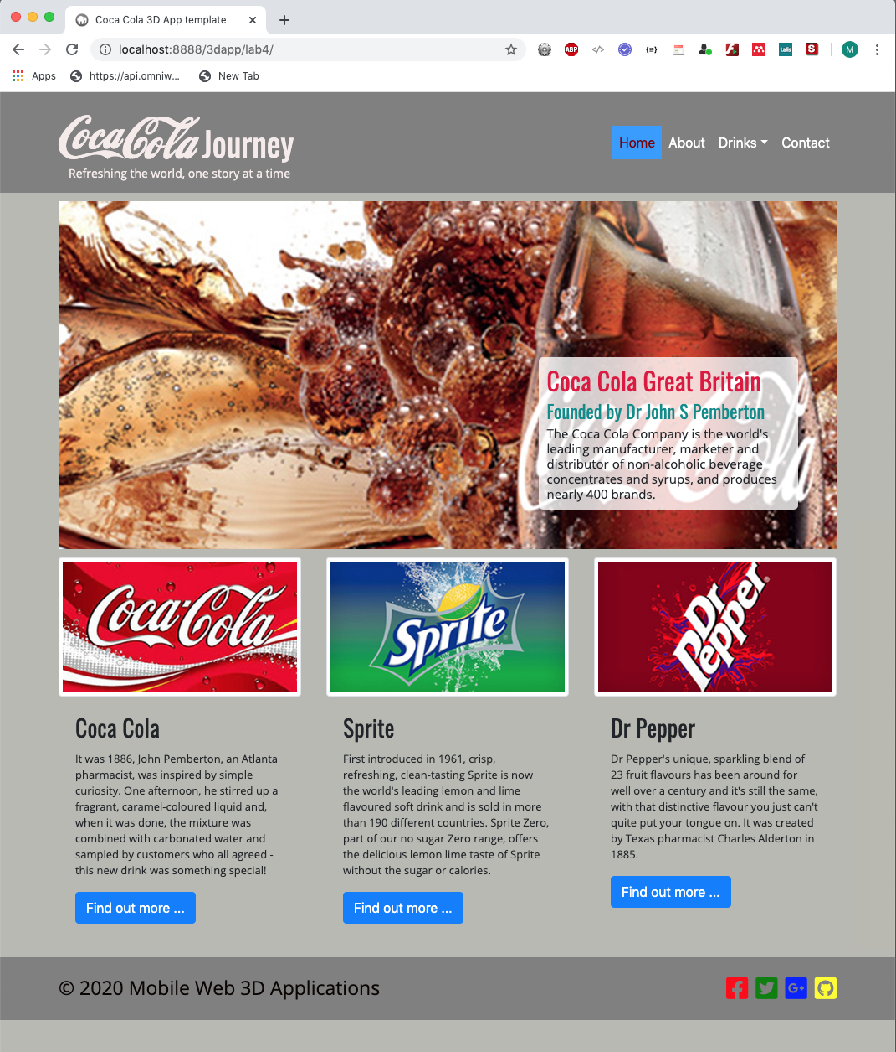

Figure 2: Fluid grid coke.html copied from the index.html ready to modify

You now need to start adapting this new coke.html page with new CSS layout and styling rules, which will involve setting up the following fluid grid layout as follows.

**Step 1**: Remove the columns with the Sprite and Dr Pepper .card components and set the coke .card component column to class="col-sm-12". Also, remove the coke image. This will make the Coke text contents stretch across the page. But, we retain the fluid properties of the .card class. See Figure 3. You can put all the original text back that you edited in Lab 1 if you wish, it should be in your assets/texts folder. Later, such contents will be asynchronously updated from a back-end server. Also, use the .container-fluid class for header, main contents and footer. That was easy, hooray for Bootstrap!

It shouldn’t be lost on you that by copying over the lab 1 template, although we will end up with a new design, we will for now keep the header and footer code and other useful codes (HTML and CSS).

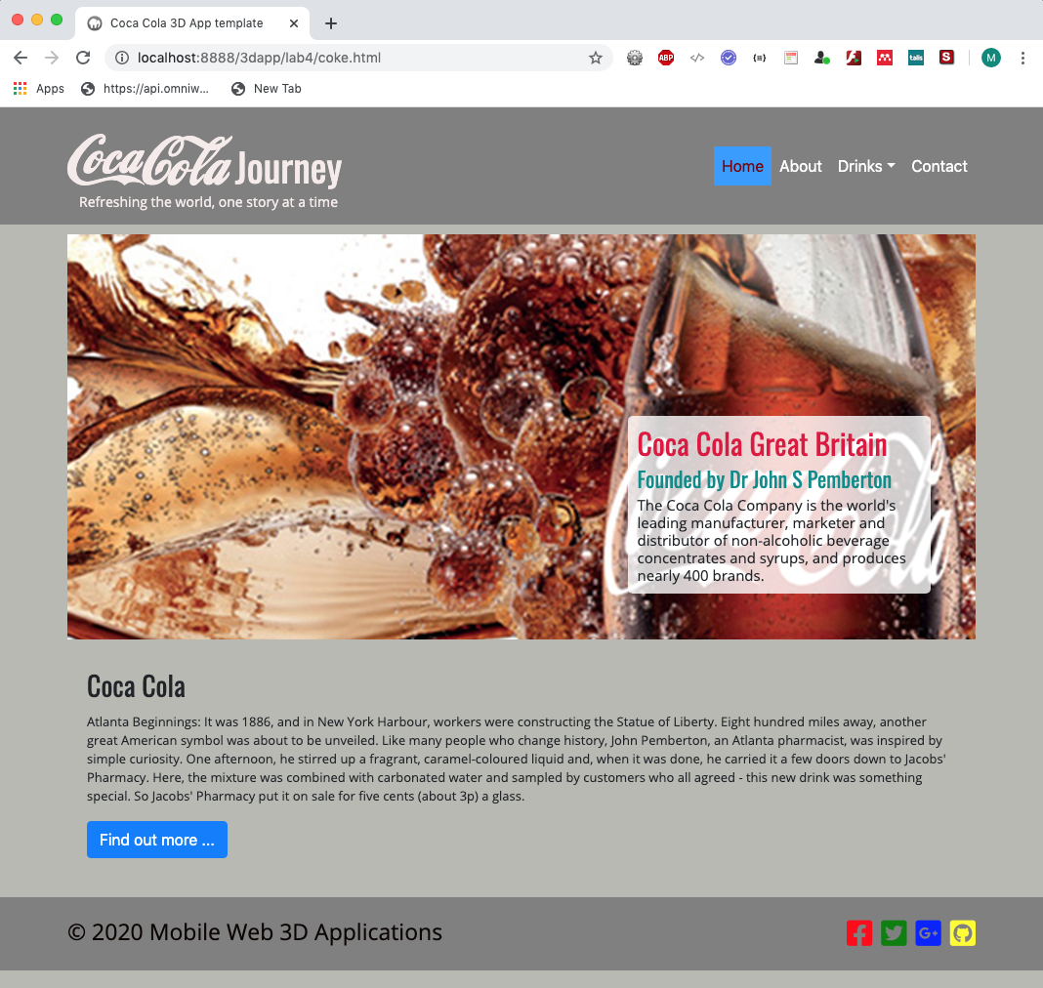

Figure 3: Step 1 — Removing Coke image, and the Sprite and Dr Pepper columns for the coke.html page

**Step 2**: You should reconfigure the layout for the 3D model, camera view buttons, and gallery links so that you end up with something like that illustrated in Figure 4. I haven’t put any design focus into this, that’s down to you, for now it is functional — save your design efforts for the assignment.

We decided above that we would use a Card, but we could consider other Bootstrap components such as a Modal or Jumbotron to hold the 3D model. I happen to know that the Jumbotron works ok, I seem to recall I had issues with Bootstrap 3 for the modal holding the 3D model, requiring a design of my own lightbox, so I will not try this here — if you have the time to look at this in Bootstrap 4, go ahead.

I happen to know that a Bootstrap 4 card has no problems embedding an X3D model, so let’s use the [Bootstrap 4 card component](https://getbootstrap.com/docs/4.3/components/card/) to hold a X3D model. Further, we will use a card header with navigation to switch between models. If you head over to the [Bootstrap 4 Components Card](https://getbootstrap.com/docs/4.3/components/card/) page you can grab an example piece of code there that you can adapt quite easily. I’ll probably grab the code from last year’s lab.

Incidentally, the Bootstrap links in this document will take you to the Bootstrap 4.3 version, you will need then to find the 4.4.1 version if you decided to switch libraries.

So far, from Step 1, you should have organised your coke.html to have 2 rows, with the first row holding two cards and the second row holing one card in the main_contents. We will use the RHS card component in the first row to hold the 3-image gallery illustrated in Figure 4, and the LHS card to hold the 3D model context. So, with 1 card for the 3D Model context, one card for the gallery context and one card for the coca cola text context we can get something like that show in Figure 4. And, we haven’t even done any CSS yet, other than that already done in Lab 1. We are relying on Bootstrap to do the heavy lifting so far — effectively we have just juggled the index.html content around t develop a template for the coke.html page.

Temporarily, we have used the backdrop main_3D image as a placeholder for the X3D model. You may recall we also over wrote the .card class border in your Lab 1 custom.css file. Again, temporarily, until we finalise our CSS code we will put the 1 pixel border back so we can see the arrangement of the cards.

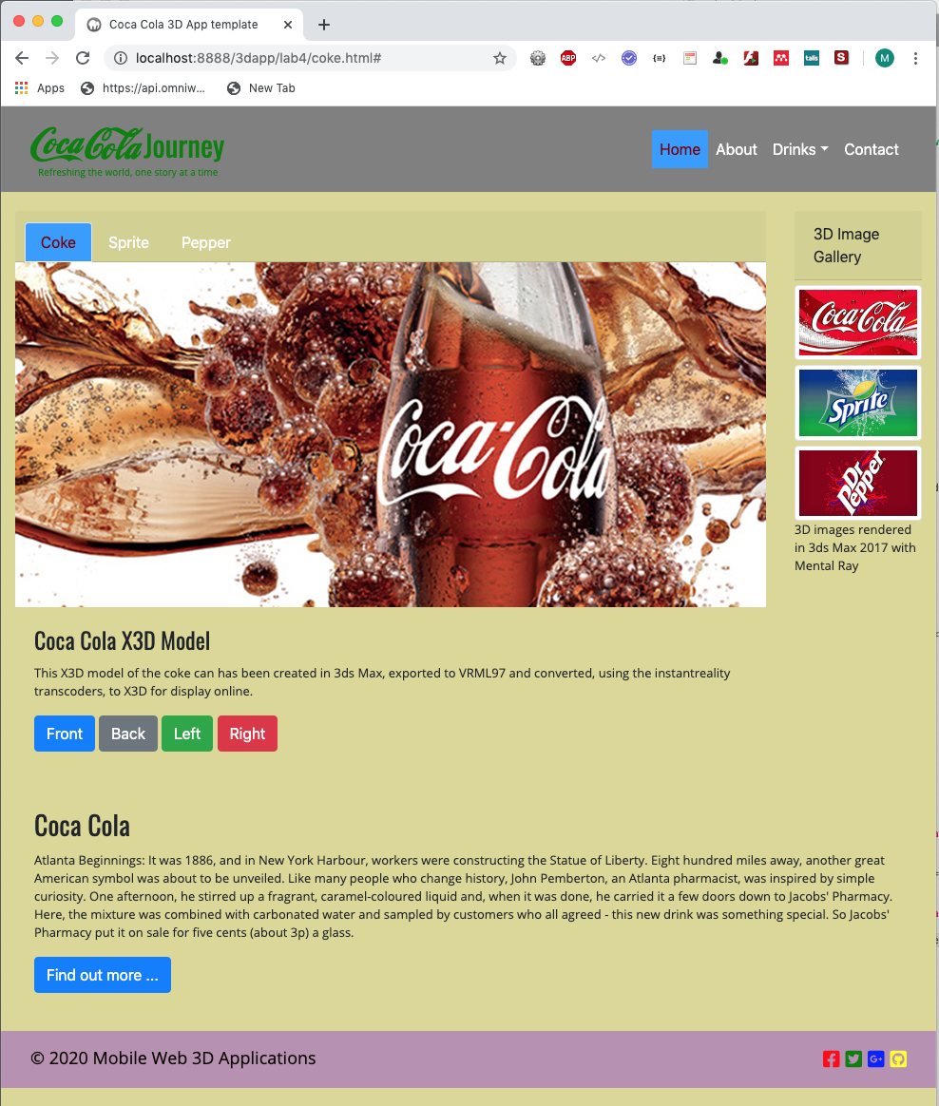

Figure 4: Step 2 — Initial adaptation of index.html into coke.html using three Bootstrap 4 cards

Clearly, we need to pay attention to styling with CSS yet. But, that’s not bad for throwing in a handful of Bootstrap 4 components.

Ok, let’s look at how we code up the HTML5 using Bootstrap 4 components to achieve the layout shown in Figure 4, starting with the main contents section, see Figure 5.

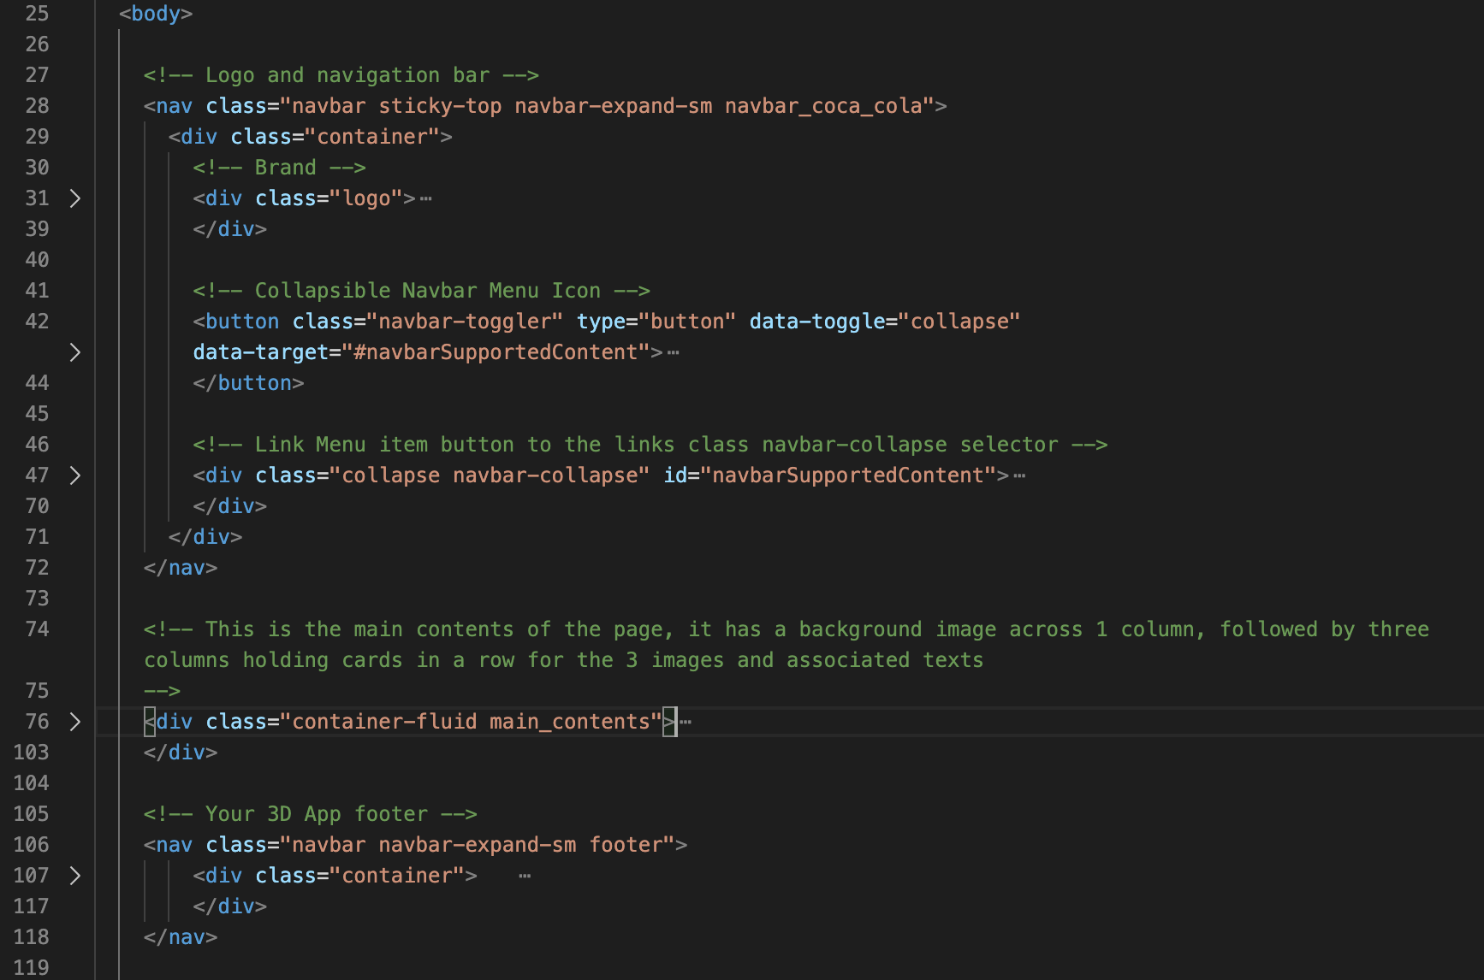

Figure 5: The Coke.html page with the header, main_contents and footer

Here, we can see that we have the header and footer as before, and also we have kept the .main_contents class we created in Lab 1. So, this layout is the same, essentially as the home page (index.html).

However, we are going to leave the header and footer as is, and reorganise the main contents section to hold 2 rows, so let’s expand that, see Figure 6 — we might find later that the .main_contents class is now obsolete. Clearly, here we can see that we have used two .row classes to hold our main contents for the coke.html page.

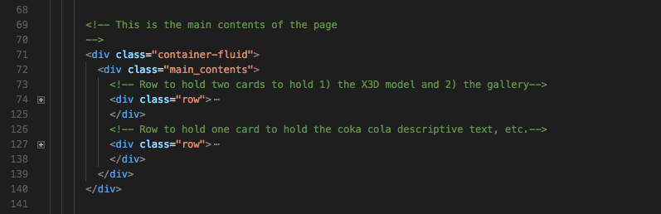

Figure 6: main contents section composed of two rows

Let’s look at the first row of the main contents section, this should hold the X3D model and the gallery code. We can see that we have set the column width to sm-10 for the X3D model, and sm-2 for the 3D image gallery, see Figure 7.

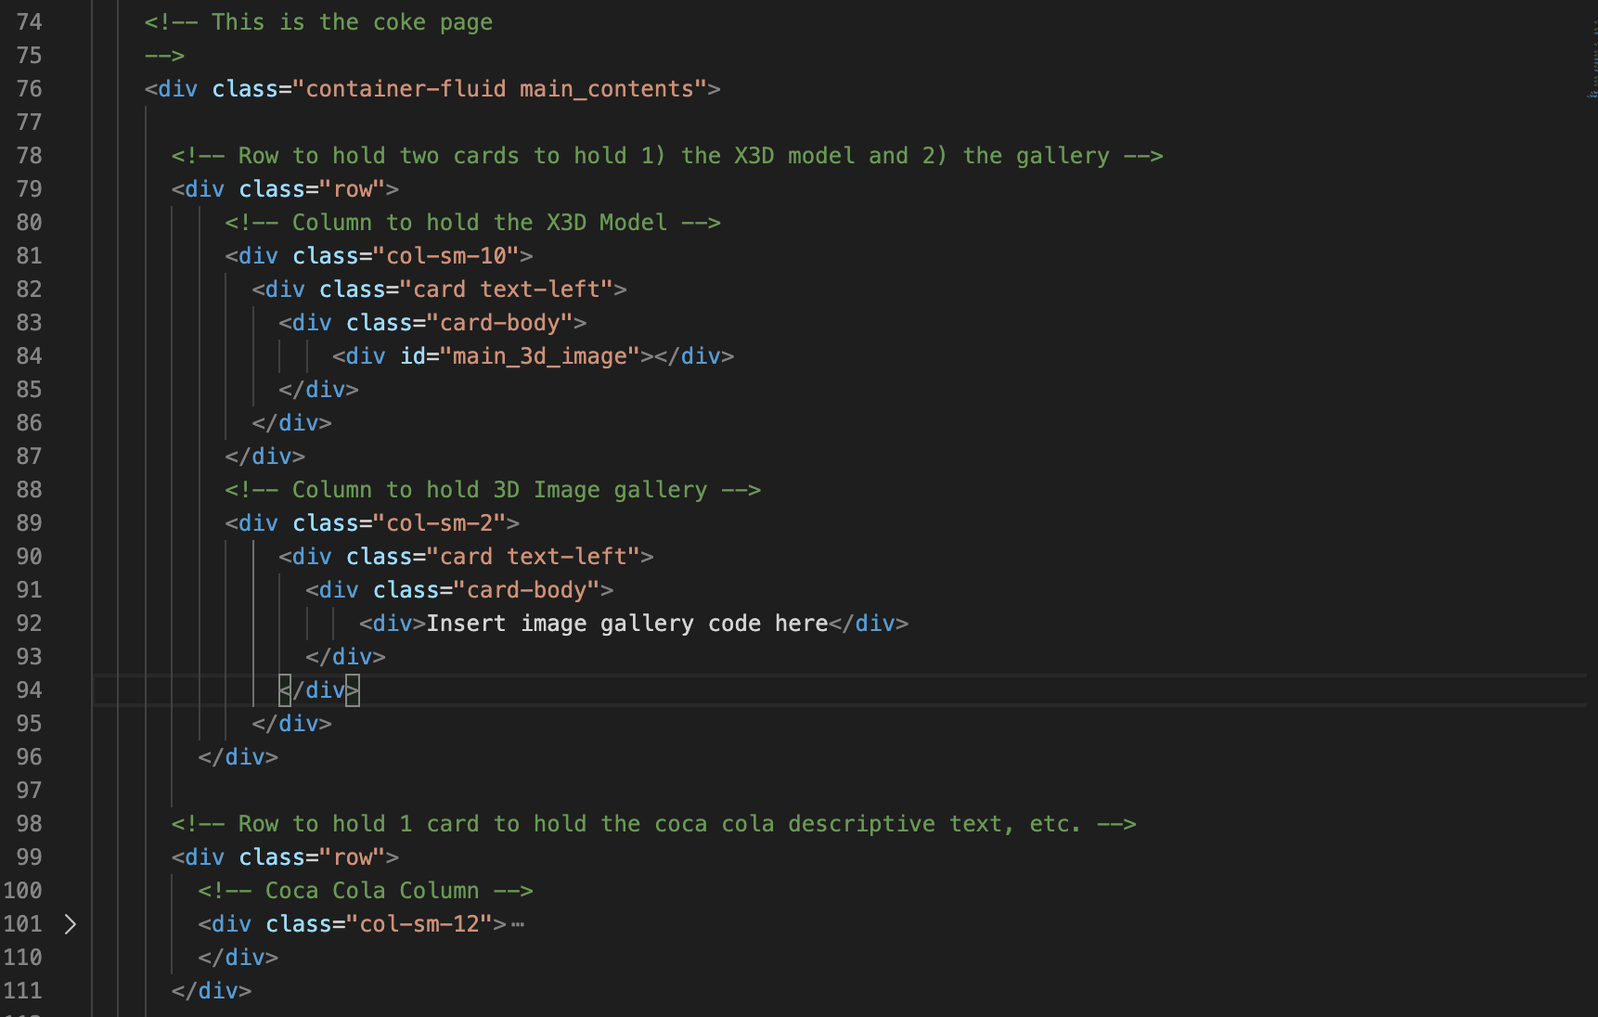

Figure 7: Two columns inserted to hold the X3D model and the 3D image gallery

Let’s look at the X3D model card, see Figure 8. Here, you can that we have used the Bootstrap 4 nav–tabs class to give us access to the coke, Sprite and Dr Pepper X3D models. Between the card header and the body, we intend to put the X3D model, but for now we have a temporary image. Then, we have the usual card body title and text. This is followed by a temporary group f 4 buttons to represent the camera view and animation controls. Later, we will look at the buttons in more detail, e.g. we may use button groups and other fonts, etc. You will nee to enter this code, take care to avoid any mistakes.

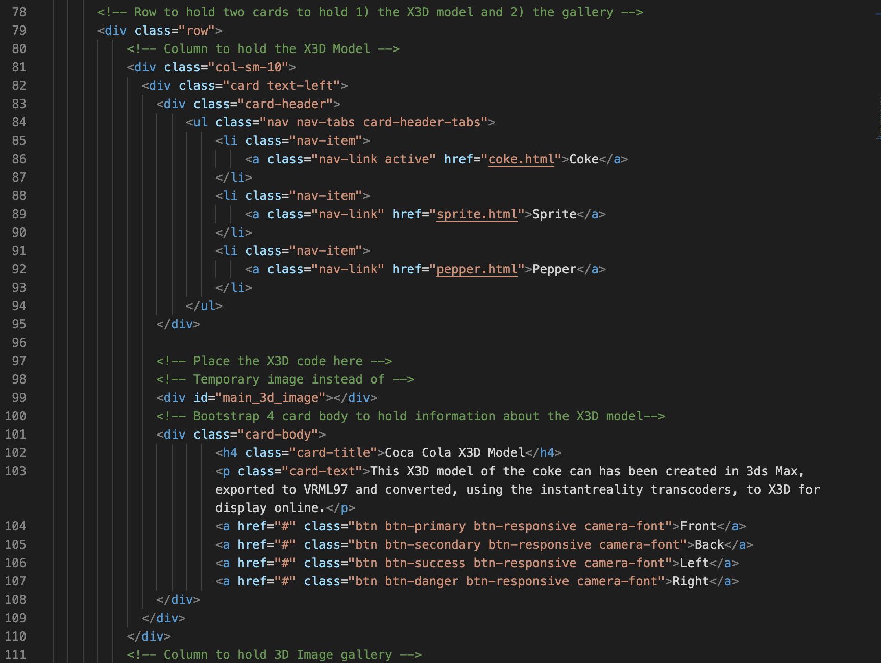

Figure 8: X3D model card with navigation header, image, body with image, title, text and buttons

Clearly, we need to do some CSS styling here, the nav-tabs for example, and the buttons, we will do this last after we have insert the X3D model. BTW, this section of code can be adapted from the [Bootstrap 4 Card](https://getbootstrap.com/docs/4.3/components/card/) example, and modified, of course. You can see we have three .nav-item classes with associated .nav-link classes and one set to active.

Let’s look at the 3D Image gallery, see 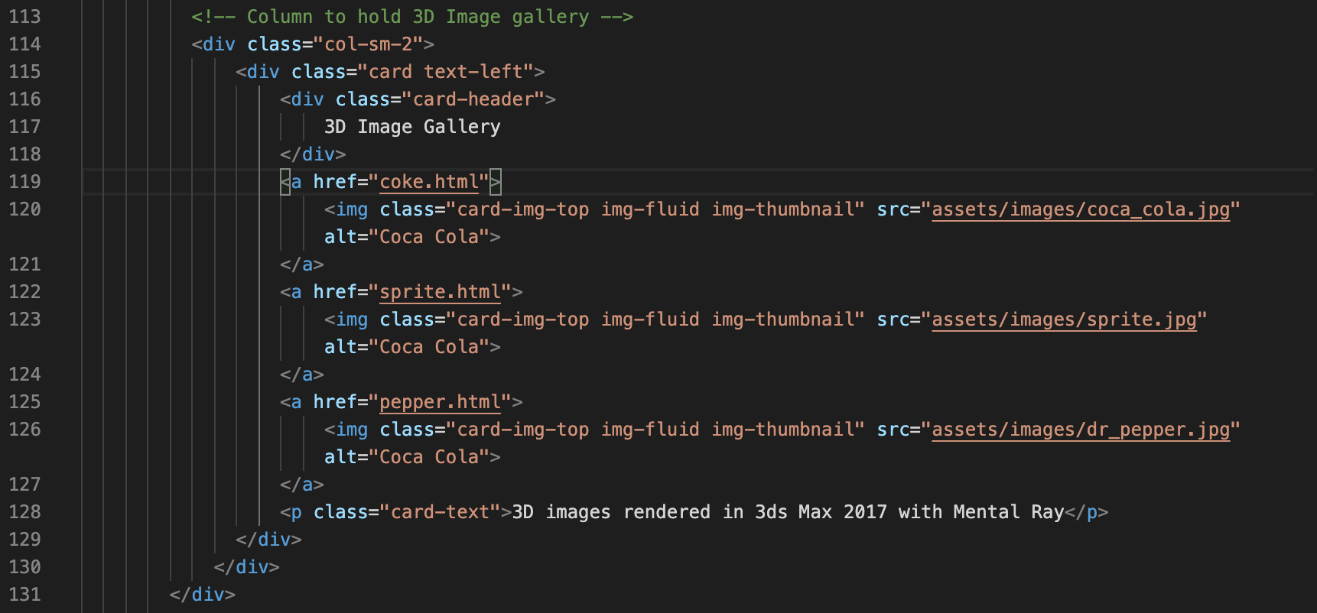

Figure 9. Later on you could render, in 3ds Max, a 3D image of each of your X3D models, which can then be used as thumbnails in this gallery. We can also connect these to a Bootstrap 4 .modal class to show an enlarged version with more information about the X3D model. But for now, we will use the images from the Lab 1 template.



Figure 9: The 3D image gallery in a card, with 3 temporary images

There is nothing new here, we have seen the card before, but clearly we need a way to overwrite the Bootstrap CSS. For example, some vertical spacing between each image

The really interesting thing so far is that because we are actually using Bootstrap classes, which are already styled in the bootstrap.css, we can effectively rough out a reasonable design quite quickly that is fluid and works. If you don’t use a library like Bootstrap, for example, you would need to create thumbnail classes for yourself, Bootstrap provides all this, and the .card class has it all built in.

Finally, let’s look at the drinks text row, see 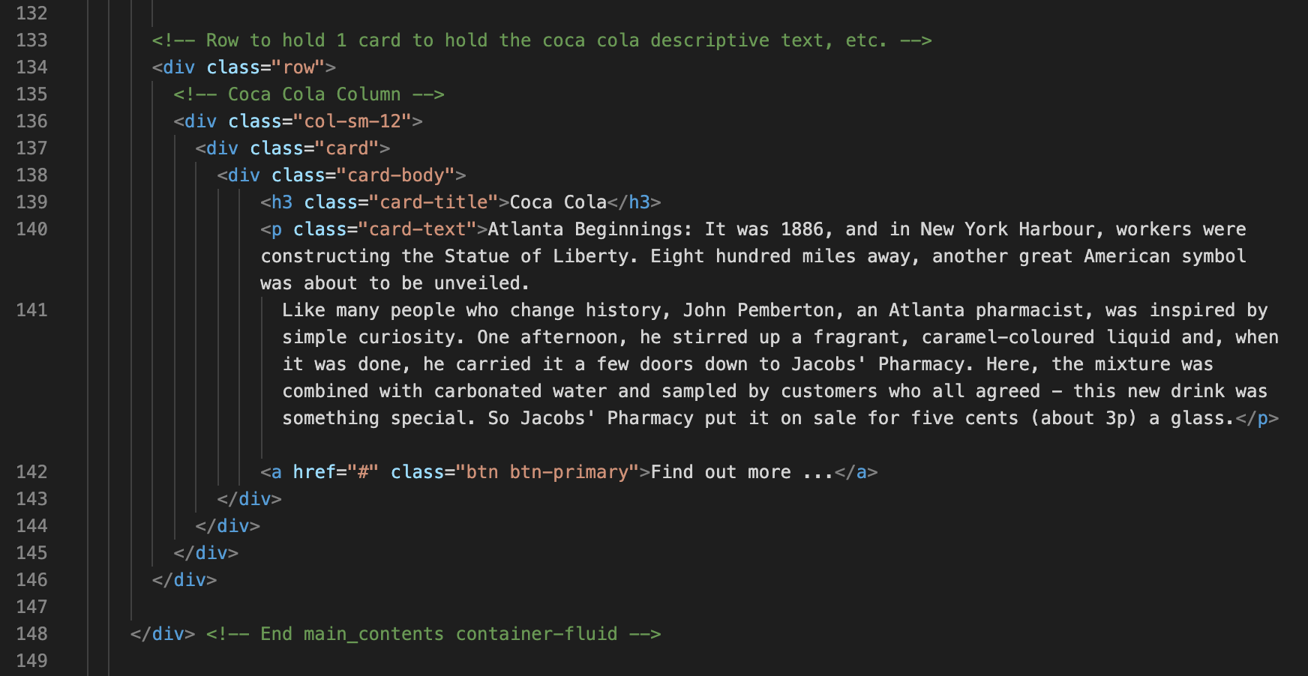

Figure 10. Here, we can see that we are using the .card class again, but without any header or image, etc. Again, nothing new here.



Figure 10: The coke drinks text inserted in a card without a header or image

So, what to do next. The only thing that is really bugging me is the 3D Image gallery spacing, but we can quickly overwrite the Bootstrap 4 .img-thumbnail class. Examine it in the Chrome Inspect Tool, copy the CSS and add a margin-top: 4px; and add this to the xs media break in your CSS file.

.img-thumbnail {

padding: 0.25rem;

margin-top: 5px;

background-color: #fff;

border: 1px solid #dee2e6;

border-radius: 0.25rem;

max-width: 100%;

height: auto;

}

I have left all the attributes here even though I am only adding the margin-top, just in case I end up tweaking some other attributes later. All, that will happen is that the original attributes will get overwritten with the, well original attributes for now.

Similarly, we can examine the Bootstrap .nav-tabs class and overwrite it. However, be aware if you use it elsewhere you will need to have a contextual class around it. These are the .nav-tabs class I just lifted from the Chrome Inspect Tool. Modify them as desired and stick them in your custom.css file.

/* Lifted form the bootsrap.css file, and modified to emulate the nav-bar menu styling */

.nav-tabs .nav-link.active, .nav-tabs .nav-item.show .nav-link {

color: #760003; /* Font color for active font */

background-color: #3399ff; /* Blue color for background */

border-color: #dee2e6 #dee2e6 #fff;

}

.nav-tabs .nav-link {

color: white;

border: 1px solid transparent;

border-top-left-radius: 0.25rem;

border-top-right-radius: 0.25rem;

}

/* Added this to emulate the nav-bar link styling */

.nav-tabs .nav-link:hover {

color: green;

border: 1px solid transparent;

}

There are other CSS styling that you can do later, for example:

* The card header background colour can be changed,
* Remove the border as a whole, or individually control each edge border,
* Play around with the column size, and so on. I just changed the X3D Model and 3D Image Gallery to 9 and 3.
* Change the color of the header texts, title texts and general text
* Investigate button groups
* Replace the actual buttons with awesome fonts
* Create your own fonts for each button function
* …

But, for now that will do, see Figure 11.



Figure 11: The new layout for Coke.html with minimal CSS changes.

You should be aware that I won’t necessarily tell you every little detail here as we move forward, it should be obvious by now that you may need modify CSS for each media screen break. You can always consult the final result in the **Live Feedback Site**, and reverse engineer.

That wraps up the basic creation of the main contents part of the coke.html page. There is more work to do here later, i.e. add the model3D and style the camera view and animation buttons, etc. not to mention actually inserting the 3D.

Figure 12 illustrates the current result for the mobile xs and desktop xl layouts. I’ll leave you to continue improving the CSS. Tip, you need to be looking use the Chrome Developer Tool to inspect what Bootstrap CSS is going and override it where appropriate.

|  |  |
| --- | --- |
|  |  |

Figure 12: The Mobile and Desktop layouts.

So, Figure 11 and Figure 12 now show the header and footer finished (for now) for all the three screen breaks and also the gallery images styled (for now).

## Consider the 3D Contents layout

At the moment, because I am using the .card class I have more or less defaulted to having the X3D model at the top of the card, below the model navigation tabs, simply because when you look at the Bootstrap specification for cards, this is where they say an image can go. I have a short title and description ready for the X3D model below the model and then I have insert some temporary buttons. But, you may prefer a totally different layout. Have a play around with the layout. For example, consider:

* Putting the X3D model at the middle, see Figure 13 — note I would need to apply margins to the X3D block element, and also the buttons to get a better alignment. But, I am not doing it now, as I will revert back to my previous arrangement in a minute.
* Move the buttons to the top, for example incorporate them into the nav-tabs, see Figure 14. Here, I have simply copied over my drop-down menu from the nav-bar in the header. Obviously, it is using the CSS styles intended for the nav-bar. So, clearly, as mentioned above you will need to change the context of the styling for the nav-bar to be independent of the nav-tab.
* Put the buttons vertically to one side or the other — this will require placing them in their own column, thus you would need to space out for three columns: buttons, X3D and Gallery; I will leave you to have a go at this.

Have a play around and come up with your preferred version. You will need to consider how your design works in mobile first, of course.

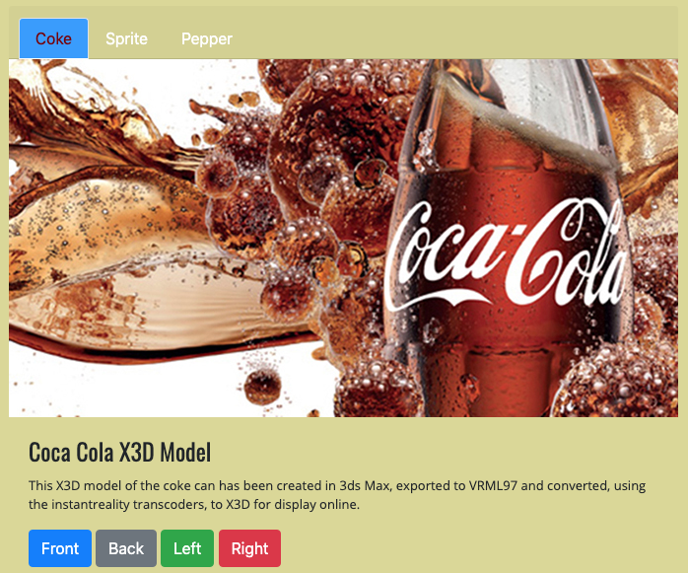

Figure 13: X3D model in the middle, no positioning of the X3D and buttons done yet

Go ahead and add the drop down navigation on the X3D model card as indicated in Figure 14.

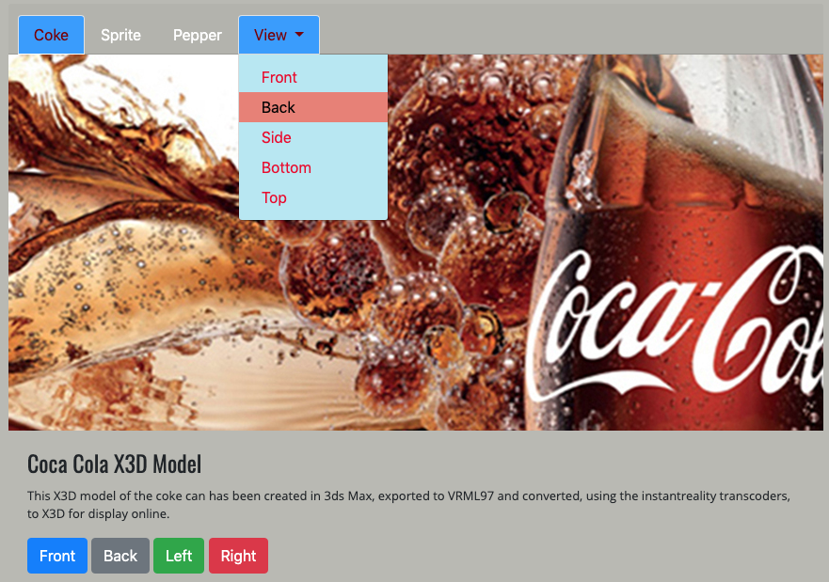

Figure 14: Add a drop down navigation to the X3D Model card nav-tab

## Consider the camera buttons panel

Eventually, when you have finished your 3D models in 3ds Max 2017, you will add a number of cameras, e.g. a perspective camera, a shot from the front, top, and so on. These camera views in X3D will link to the camera or view buttons in your 3D App. I suggest, just to get started, that you create a small subset of possible buttons with which to attach to their corresponding camera views later in Lab 5, something like:

* Front
* Back
* Left
* Right
* Top
* Off

This might be too many buttons for the mobile view, but eventually you may use other techniques to collapse the camera buttons, e.g. a drop-down camera menu, or smaller fixed sized icons developed from font awesome, etc. To better style the buttons, also we will create a .camera-btns class.

We will use Bootstrap’s button stack for our camera-btns group, restyle it and make it responsive. Later, I might change to Bootstrap Split buttons as a way of grouping other Interactive functionality. If you want to do the same have a look at w3schools [BS4 Button Groups](https://www.w3schools.com/bootstrap4/bootstrap_buttons.asp). In particular, try out the [Vertical Button Groups](https://www.w3schools.com/bootstrap4/bootstrap_button_groups.asp). You can adapt my following example:

<h5 class="card-subtitle">Camera Views</h5>

<div class="camera-btns">

<p class="card-text">These buttons select a range of X3D model viewpoints</p>

<div class="btn-group ">

<a href="#" class="btn btn-primary btn-responsive camera-font">Front</a>

<a href="#" class="btn btn-secondary btn-responsive camera-font">Back</a>

<a href="#" class="btn btn-success btn-responsive camera-font">Left</a>

<a href="#" class="btn btn-danger btn-responsive camera-font">Right</a>

<a href="#" class="btn btn-warning btn-responsive camera-font">Top</a>

<a href="#" class="btn btn-outline-dark disabled btn-responsive camera-font">Off</a>

</div>

</div>

And, the CSS, this for the Mobile:

.camera-btns {

/* background-color: rgba(0, 0, 255, 0.3); */

border-color: black;

border-style: solid;

border-width: 0px;

margin-top: 0px;

padding: 0px;

}

.camera-btns > p {

font-size: 15px;

color: red;

padding-left: 0px;

font-weight: 900;

}

.camera-font {

font-weight: 400;

color: white;

}

.camera-font:hover {

font-weight: 700;

color: rgb(3, 3, 3);

}

.btn-responsive {

padding: 6px 10px;

font-size: 90%;

line-height: 1.2;

white-space: normal !important;

}

Remember, if you are not sure where this code go, check out the **Live Feedback Site**. Incidentally, you might want to set the border of the card class to 1 px while you are designing the layout, I find it helps to see where the position of each component is relation to each other, and temporary setting a 1 pixel border helps in debugging layouts — it also throws into stark relief

So, I have now, more or less, set up the CSS here for the mobile xs media break point. The reason for creating the .btn-responsive and .camera-font classes is to get a better control over the Bootstrap 4 buttons. Remember, we said earlier that we will need to override as much Bootstrap CSS as necessary to make your 3D App look like something you designed, not Bootstrap. After all, when I come to mark your work, who do I send the marks to, you or Bootstrap!

You will need to scale up for the tablet and desktop. Notice the **white-space: normal !important;** CSS rule. This allows the button text to wrap inside the button. In reality, for your assignment you might like to design or use icons for your camera buttons?

So, that worked quite well, but obviously we will have to create CSS rules to override the Bootstrap styling, we will get to that later. We will change the font color, size, link, hover, etc. properties and get the interaction panel to scale with the screen size later

Figure 15 shows the camera buttons inserted in the mobile (xs) view propagating through to the desktop (xl) view. So, you will need to modify for each of the rest of the media screen breaks.

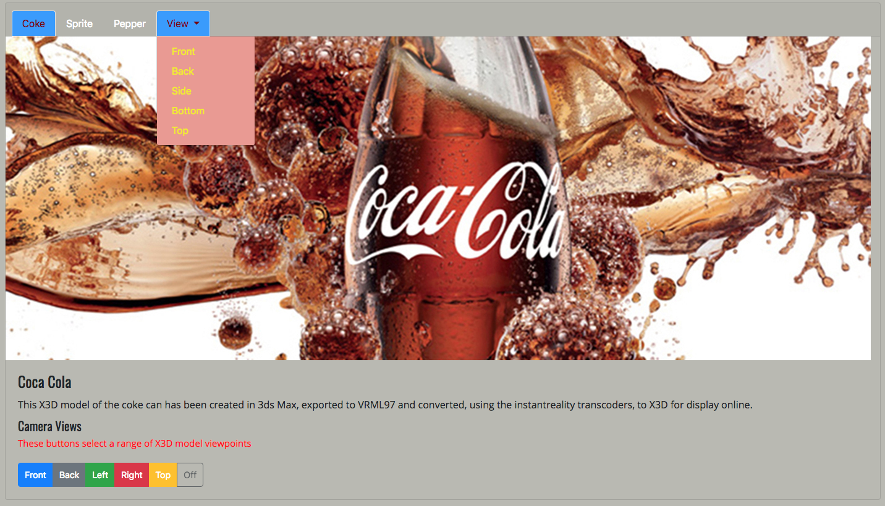

Figure 15: Large desktop view with a Bootstrap 4 button group restyled with a modicum of CSS

Of course, the CSS given above was my design, you will most likely want to create your own button styles for your design, otherwise your buttons will assume the Bootstrap default styles. Figure 16 illustrates the button font-size and padding I have used for the some of the media screen breaks.

|  |  |  |
| --- | --- | --- |
| Macintosh HD:Users:martin:Desktop:Screen Shot 2017-02-21 at 00.59.40.png | Macintosh HD:Users:martin:Desktop:Screen Shot 2017-02-21 at 00.59.16.png | Macintosh HD:Users:martin:Desktop:Screen Shot 2017-02-21 at 00.58.52.png |
| Mobile | Tablet | Desktop |

Figure 16: Making the Bootstrap buttons responsive across the screen media breakpoints

Note, also I demonstrated, in Figure 15, the use of the default Bootstrap button colour schemes. Bootstrap provides several button formats: default, primary, success, info, warning, danger, and link. Again, have a play on [w3cschools Bootstrap Buttons](https://www.w3schools.com/bootstrap4/bootstrap_buttons.asp) to learn how to use them.

So, we could spend a lot more time on this layout working on the buttons including a complete redesign. But, this will do for now for the buttons. However, I just noticed that the Gallery images are banged up against the card border. You could insert some margins somewhere to control this better, but the reason it is like this is because we haven’t actually crated a card body yet, so do this now. Then, move the gallery images into the top of the body and adjust the .img-thumbnail margin-top and margin-bottom to get a better spacing between images; the .card-text class aligns each image at 100% width inside the card body. Also, add a margin-top for the card-text class in your CSS. I also made the X3D model in the first row 9 columns wide and the Gallery 3 columns wide on the grid, but you can adjust the layout as you wish.

While you are doing this, it occurs to me that the X3D model would be better in the card-body as well, so change this too. And, change the font colour for the gallery .card class header to match, see Figure 17

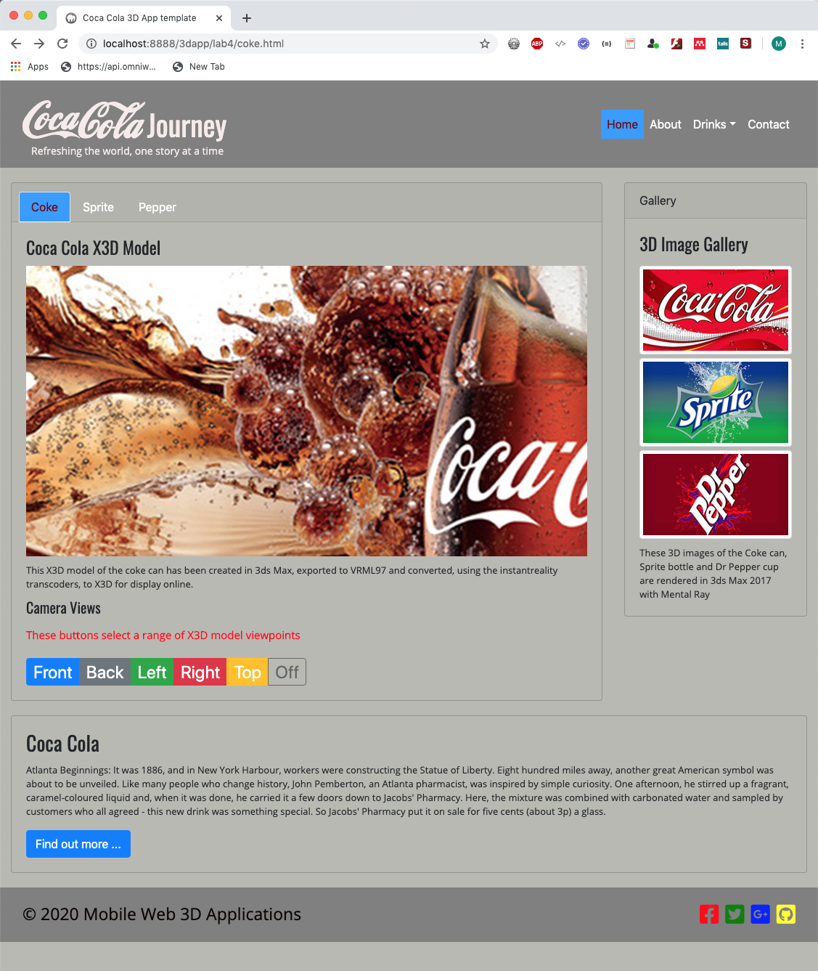

Figure 17: Layout and CSS adjusted for the X3D model and gallery cards

Let’s continue with replacing the temporary image with the X3D model.

## Add the X3D Model

As you can see from Figure 17 we have already created a block element, i.e. a card class, to hold the X3D model. So, you now need to insert the X3D model (or code) starting with your coke.x3d model.

But first, you need to make sure that you have your 3ds Max models exported and converted to X3D inline format. If you do not have these ready yet, then you need to go back to Lab 3 and create these X3D models. Once you have your three X3D models you can save them along with their textures in an x3d folder and then place these in your lab 4 working folder. If you haven’t already done add an x3d folder to your assets folder to hold your X3D models. Your project file structure should look something like that shown in Figure 24.

Tip. If you find that when you have inserted your X3D model into your coke.html page and the textures don’t show, it may be that you exported with your textures going to the sceneassets/ folder. If so you will have to either go back into 3ds Max and export again to reflect this Lab 4 structure x3d/maps or more easily, just open up your coke.x3d file and change:

<ImageTexture url='"../sceneassets/images/can_texture.jpg"'/>

to:

<ImageTexture url='"maps/can_texture.jpg"'/>

Do the same for the other two (sprite and pepper) X3D models.

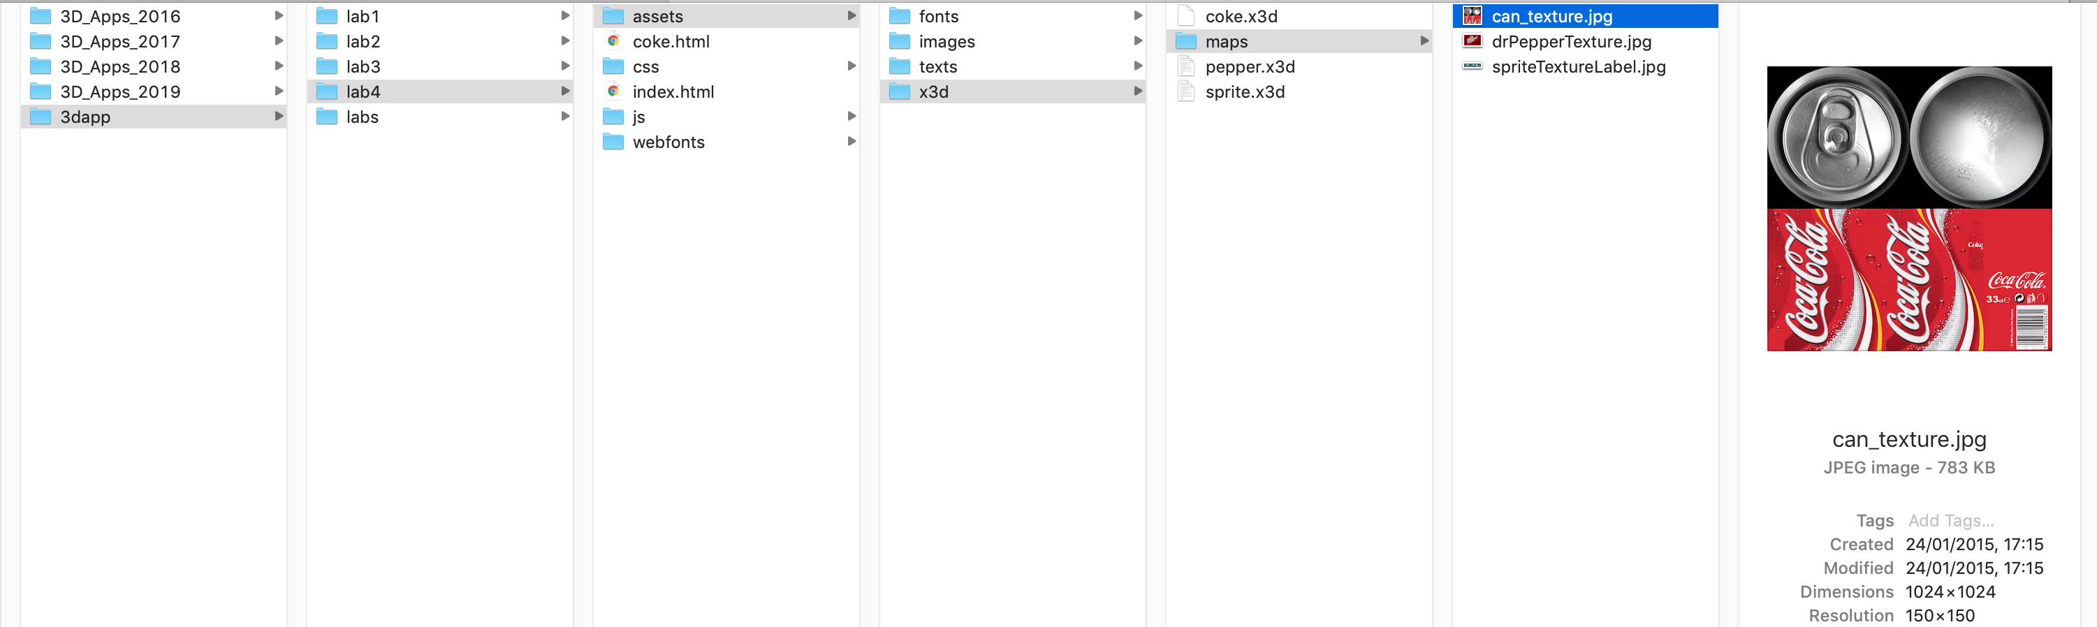

Figure 18: Your X3D files organised as assets in your Lab 4 work.

You will need to have converted your 3ds Max models into the X3D format ready to include as an inline x3d file in your HTML. Your X3D code should look like that should in Figure 19. To create the inline version of your X3D models, you can follow the tutorial on the [www.x3dom.org](http://www.x3dom.org) site that shows you how to [include an external X3D file](http://doc.x3dom.org/tutorials/models/inline/index.html). Remember how to convert your VRML file to X3D form Lab 3. Once you have your X3D file and it in integrated (via inline) into your HTML5 document, you then have X3DOM (i.e. X3D in the Document Object Model), and you can still manipulate the X3D nodes with JavaScript using a namespace — also seethe description on how to include an external X3D file in Lab 2 tutorial. We also show many examples in [Ben’s Kitchen](http://web3dapps.org/ben/x3dom.php) (stable version) and [Ben’s Kitchen](http://benskitchen.com/x3dom.php) (latest version) that we mentioned at the beginning of this tutorial.

In Figure 19 note the url for the texture maps, and also note the indexedface set, this is often massive, you can’t see most of it because I deliberately turned off word wrap. This is why we like to use an inline X3D file, because this would make your HTML file unmanageable, **and a good way to lose marks when I open your 3D App source code!**

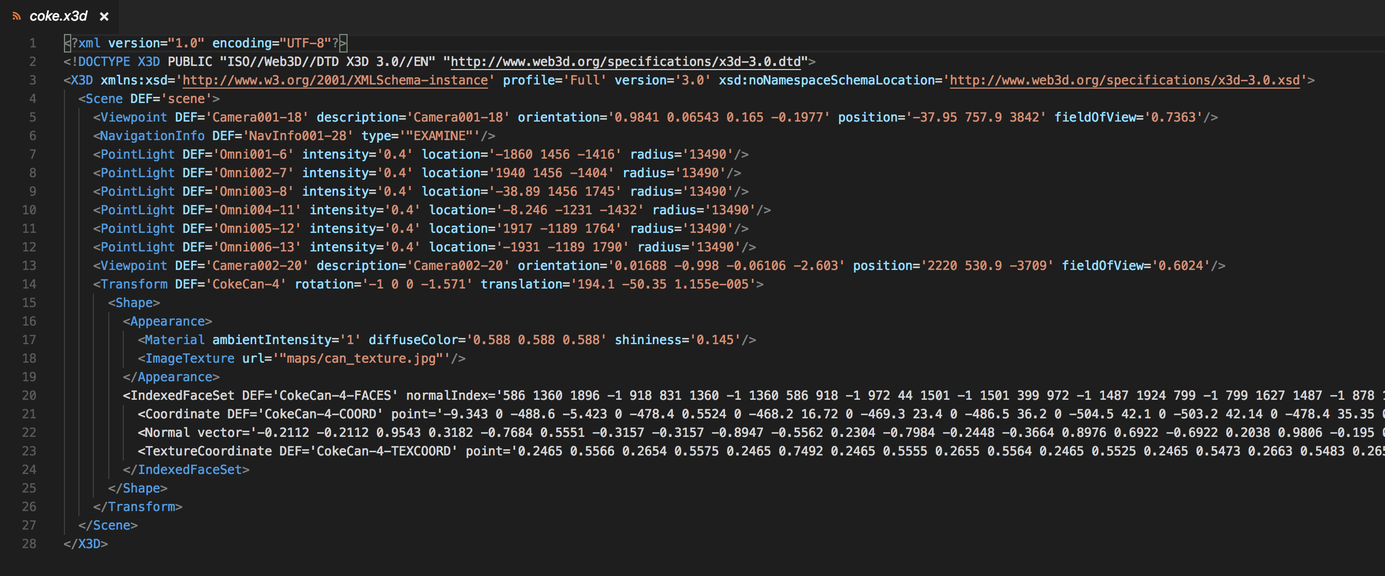

Figure 19: Coke can model converted to an X3D for embedding as an inline X3D model.

You will also need to link the x3dom CSS and JS files:

<!-- X3dom -->

<link rel='stylesheet' type='text/css' href='css/x3dom.css'>

<!-- Include the x3dom JavaScript -->

<script type='text/javascript' src='js/x3dom.js'></script>

Notice here that I have downloaded the x3dom CSS and JS files and installed is the css and js folders, you can [Download X3DOM](https://www.x3dom.org/nodes/) and we recommend picking the current stable release version, and use that for your assignment just in case the X3DOM server goes down just as you are desperately trying to finish your assignment!

To embed your coke.x3d model into the coke.html page, use the code illustrated in Figure 20, notice I commented out the temporary placeholder image: main_3d_image.

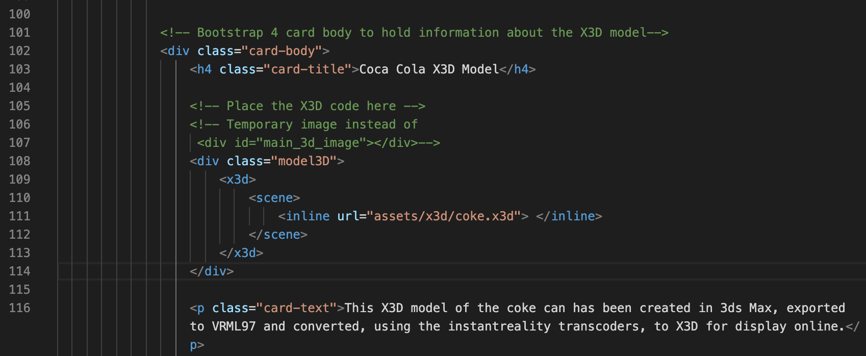

Figure 20: Integrating your X3D model inline.

Further, you will need to create the .model3d class CSS rules and also X3D rules to overwrite the x3dom.css X3D rules. For now, create the following rules just to ensure we have the coke.x3d model positioned ok — BTW, I have also given you my CSS rules to overwrite the gallery .card class header CSS.

.gallery-header {

color: white;

}

.gallery-header:hover {

color: green;

border: 1px solid transparent;

}

.model3D {

background-color: rgba(255, 255, 255, 0.2);

border-radius: 5px;

border: 1px solid rgba(0, 0, 0, 1.0);

padding: 2px;

height: 200px;

}

X3D, x3d {

border-radius: 5px;

border: 1px solid rgba(255, 0, 0, 1.0);

width: 100%;

height: 100%

}

This ensures we have a sufficient initial space to insert the X3D model in the mobile small device media screen break, see Figure 21.

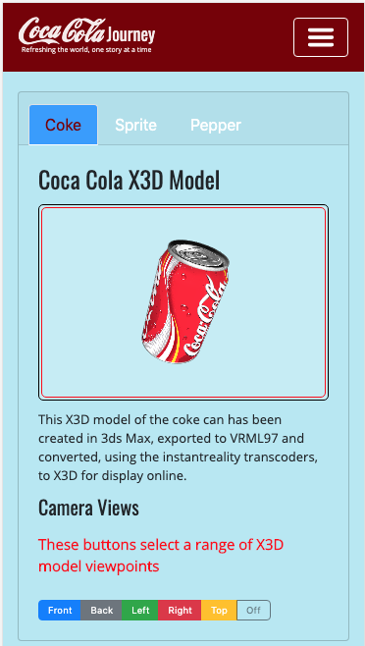

Figure 21: The mobile (xs) media break layout styled to insert the X3D coke model

You can see if you look at the CSS rules, that I have overridden the inner x3dom.css rules for the border, which I colour RED, and also created a border black for the .model3D class. Later, you can switch these off by setting border to 0px. I find it useful early on to show a border so that I can see effectively the block elements, and how it might be impacting other block elements. I also gave a different background colour to the .model3D class, which can be changed or set to transparent for better blending in the page. We can do this later in a final tidy up of our CSS, or as you go along.

In the meantime, it is instructive to open the x3dom.css file and have a look at the CSS rules, there is not a lot there, and the CSS rule of most interest to us in order to blend the X3D model into your 3D App is the X3D, x3d CSS rule, see Figure 22. Rather than modify the x3dom.css, assuming you downloaded it, it is probably a better idea to copy this CSS rule to your custom.css file and then modify it. You can then declare the standard x3dom.css file at the top of your HTML, and make sure your custom.css rules over rides the x3dom.css rules by placing the x3dom.css above your custom.css file.

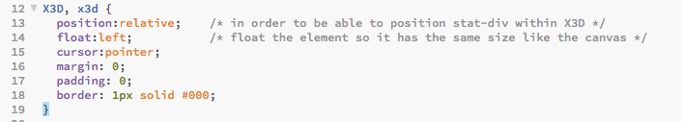

Figure 22: The X3D CSS rules located in the x3dom.css file

You can see from the CSS code above that for the X3D model inserted into the mobile xs media screen break, we choose a height of 200px, and scales the X3D CSS rules to scale height and width 100% into this the .model3D class. Clearly, we need to set appropriate heights for all the media screen breaks, see 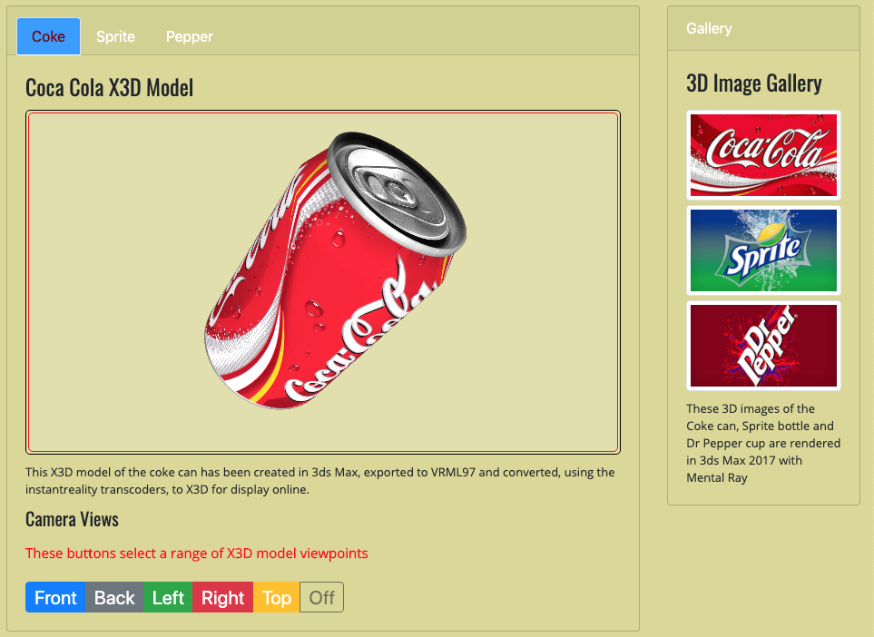

Figure 23 and Figure 24 illustrates the X3D Model height adjusted for larger screens. I’ll leave you to do that — you should also make sure that your initial camera view on load makes use of the height you choose — see the **Live Feedback Site**.



Figure 23: Partially completed layout for larger screens

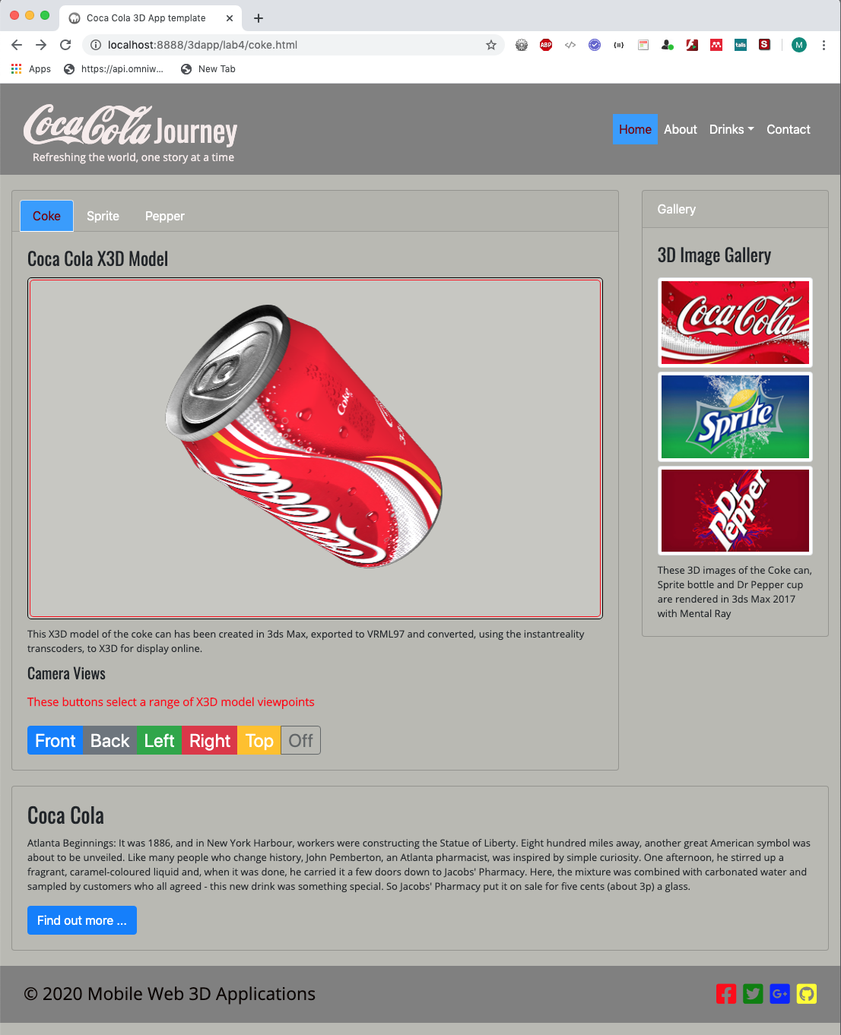

Figure 24: Column widths and X3D model heights adjusted for the media screen breaks.

Your HTML5 code for the main contents should now look something like that shown in Figure 25. However, you can access this code on the **Live Feedback Site** for comparison with yours, e.g. as a debugging aide.

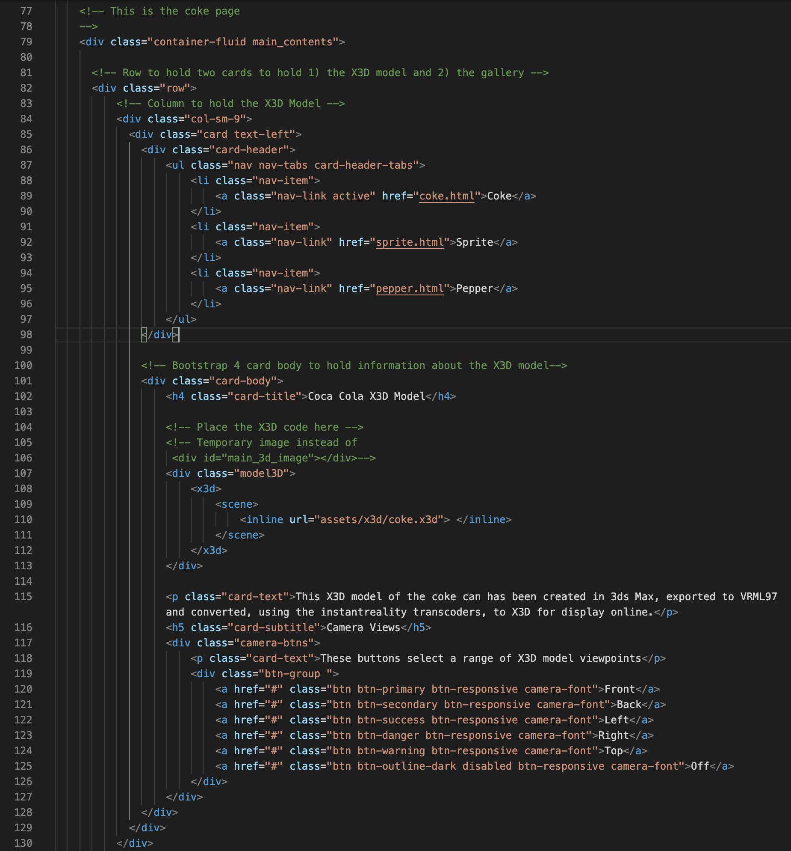

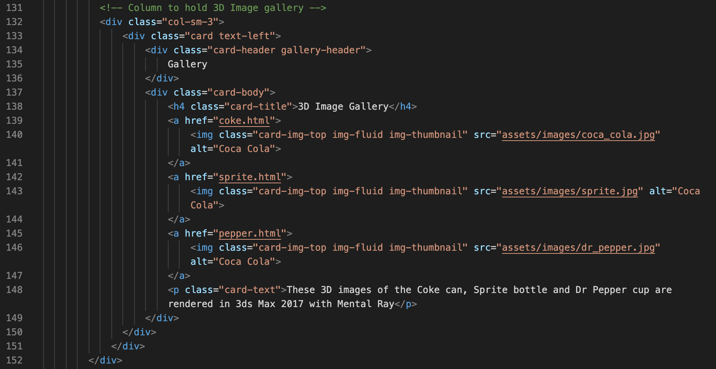

Figure 25: HTML5 code corresponding to Figure 24 fluid grid layout.

As you can see, we have used an inline X3D coke model, embedded (or written into) in the main3D div tag along with the camera-btns and the 3D image gallery, which you can link up later. We haven’t done anything with gallery links yet, other than style them for fluid grid (i.e. make them responsive). Obviously uses for the camera-btns are to connect these to the associated X3D camera view code to select the desired camera. But, at this point in time my X3D does not contain these camera views — an example of how to connect up the camera buttons is given in Lab 8.

# Interaction 3D Buttons

You need to create some kind of interaction around the X3D model by manipulating the camera view, control an animation, have some lighting control, and so on, for example:

* If you haven’t already done so, then go back to 3ds Max and create some useful camera views, e.g. front, back, top, bottom, side, perspective views, etc.
* In 3ds max create simple animations for your coke, sprite and pepper models so that you can trigger these from a start and stop animation button. Just do a simple rotation of the 3D model
* In 3ds Max create a selection of light sources that you can turn on and off from a button panel

Once you have these basic interaction components added to your 3D models, they should export with your 3D model and convert to X3D.

## JavaScript code for 3D model Interaction

If you want to have a peek ahead at how to connect up buttons to X3D code via JavaScript in X3Dom, see Appendix 4 — Connecting buttons to X3D code via JavaScript in X3DOM.

# 3D Image Gallery

You have created a 3D image gallery. You can use this later (Lab 5) for several things, e.g. it could be used as links to load a new model, or simply act as the thumbnail for a light box to show 3D images of the current model. We will implement the latter option in Lab 5, because we already have plenty of ways to load the different models. For now, you can leave the links unconnected or link them to the corresponding coke, sprite or pepper HTML pages.

To prepare for Lab 5 you could prepare suitable renderings in 3ds Max for your coke, sprite and pepper models. Later in Lab 5, you will put your 3D images into an asset folder, which we will use PHP to extract the image and add to the gallery.

# Complete the HTML5 and CSS3 for coke.html

We have nearly competed the code for the HTML5 page — Figure 26 shows all the HTML5 code so far with the support libraries. You can check this against your own code, or look at the **Live Feedback Site** for the actual code, which may be more advanced than that shown in Figure 26. Please note, the **Live Feedback Site** is there to allow you to compare and contrast, particularly if your code doesn’t work for some reason — use it as a learning tool, not as a repository from which to simply copy the code:

|  |
| --- |
|  |
| CSS libraries — note custom.css is last so that it overrides any bootstrap or x3dom CSS as necessary |
|  |
| Logo and navigation menu |
|  |
| Main contents for the coke page — the X3D model in a card with navigation tabs and buttons |
|  |
| Main contents for the coke page — the gallery 3D images in a card |
|  |
| Main contents for the coke page — the coke description in a card |
|  |
| Footer and JavaScript libraries — javaScript is usually put at the end to execute after the DOM is loaded |

Figure 26: The HTML5 code so far for coke.html

Now we need to finish off the CSS for Lab 4. I will leave you to do that. So far, from mine I can think of several improvements that could be done:

* I haven’t created any CSS rules for extra-large devices, i.e. min-width: 1200px
* I haven’t propagated correctly all desirable CSS changes from xs through to xl
* I could devise a new colour scheme for each media break, I was just playing a round above
* Fonts sizes across all media screen breaks need some attention.
* Blend the background colour of the X3D model into the page better, e.g. remove borders, make same background color, etc.
* Adjust spacing for the X3D nav-tab
* Tweak the camera buttons
* Add animation, lighting, etc. buttons — you could also finish this in Lab 5
* …
* Oh, and I haven’t linked up the ‘Find out more …’ buttons, use the following:
  + <http://www.coca-cola.co.uk/drinks/coca-cola/coca-cola>
  + <http://www.coca-cola.co.uk/drinks/sprite/sprite>
  + <http://www.coca-cola.co.uk/drinks/dr-pepper/dr-pepper>
* And, you might find somewhere to link up the social media icons on the footer.

I am sure I will spot many other tweaks I can do as I go along, as you will. However, Figure 27 shows my final coke.html page so far after adjusting the CSS, in particular I have turned off the X3D boarders temporarily and made their background transparent to show how the 3D model blends into the web page well.

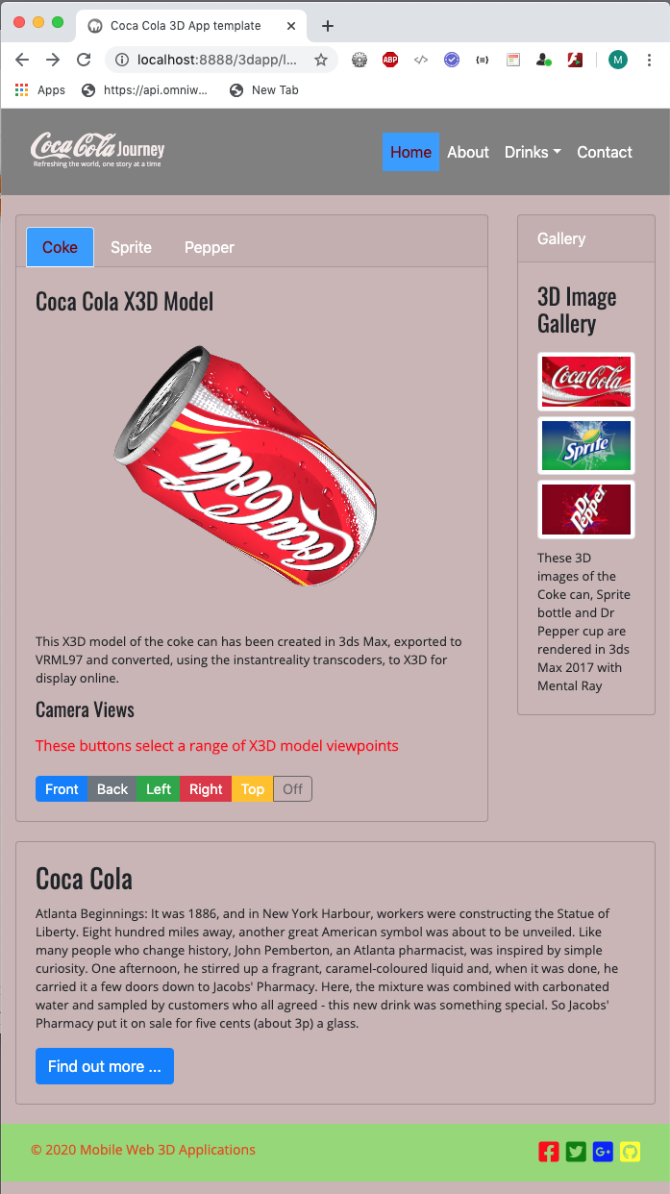

Figure 27: Coke page layout desktop — see **Live Feedback Site** for final versions

I may have forgotten to show you a CSS rule or two, but you can access the complete set of CSS rules in the custom.css file in the Lab 4 results online at the **Live Feedback Site**, where you should navigate to Lab 4. As before, use the Chrome Inspect element resources tool to examine the site.

# Create the Sprite and Dr Pepper pages

All that remains in Lab 4 is to:

* Create a new page for the Sprite bottle and the Dr Pepper cup by copying the coke page and modifying as needed
* Link up the navigation menu links, i.e. the X3D model nav-tab links could be linked to the different pages, the dropdown menu on the nav-bar needs linking, the Home can link to the index.html page. We don’t have any content for the About and Contacts nav-bar links yet, see below. The Find out more … buttons can be linked to the same links as in Lab 1, i.e. to corresponding Coca Cola web pages that describe these drinks in more detail.
* Tidy up any outstanding CSS anomalies
* Test all four pages: index.html, coke.html, sprite.html and pepper.html
* Finally, review your design, make a note of improvements that could be done, and carry them out

## Add some About and Contact Contents

As an exercise, head over to the Bootstrap 4 components site, examine the popover and modal components, and then implement them for the coke, sprite and pepper pages:

* A popover for the About menu link — as usual w3schools has some example for the [Bootstrap 4 Popover](https://www.w3schools.com/bootstrap4/bootstrap_popover.asp), Figure 28 illustrates use of a popover if you use the following code adapted from the w3schools examples. It will be interesting to figure out how to inject the content from the back end eventually!  
    
  **HTML:** Modify your nav-bar link for About

<a class="nav-link" href="#" data-toggle="popover" data-trigger="hover" data-placement="bottom" title="About Web 3D Applications" data-content="3D Apps is a final year and postgraduate module ...">About</a>

**JavaScript:** Put this in a new file called custom.js, and declare it in your JS paths at the bottom of your HTML files

$(document).ready(function(){

$('[data-toggle="popover"]').popover();

});

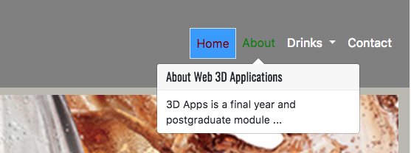

Figure 28: Example use of Bootstrap 4 Popover

* A modal for the Contact menu link — as usual w3schools has some example for the [Bootstrap 4 Modal](https://www.w3schools.com/bootstrap4/bootstrap_modal.asp), Figure 29 illustrates use of a popover if you use code adapted from the w3schools examples, I won’t bother listing it here because I used it virtually as is. However, you will need to adjust the CSS rules for visiting nav-bar Contact link to get rid of the ugly blue border! You will explore modals more later in other labs.

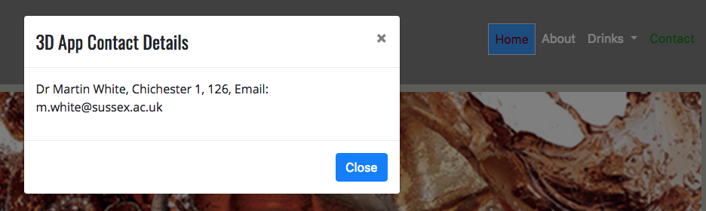

Figure 29: Use a modal to implement the contact details

If you were not going to convert all four 3D App pages, index, coke, sprite and pepper into a SPA, I would say don’t forget to modify the About and Contact links for the coke, sprint, pepper pages as well as the index page. But, as you will be converting your work in this Lab 4 to an SPA based 3D App in Lab 5, this would be a waste of time.

# Lab 5 — Interactivity with JavaScript and PHP

Next week we will add some simple JavaScript and PHP to make your basic 3D App more interactive and dynamic. For example, we will convert the site into a single page layout using a simple JavaScript swap function to hide and swap in container div tags for the home, coke, sprite and pepper contents. This will effectively make your 4-page 3D App a basic SPA version of a 3D App.

We’ll also develop some simple JavaScript to interactively change the SPA page theme, and we’ll add a simple PHP based gallery (by way of a quick introduction to some PHP code) to populate the 3 images with your 3D images that you will store in your assets folder (assets/images/3D_images).

# Appendix

## Appendix 2 — Previous Lab Results

### Week 1 Results

You will adapt the web page you created in Week 1 as your home page for your simple 3D App. If you have not completed this yet, you are well behind and need to get a move on, see Figure 30.

If this web page is not finished, go back to the week 1 laboratory tutorial and complete it. If it is finished, continue to the next section.

|  |  |
| --- | --- |
| ../../../../../Desktop/Screen%20Shot%202018-01-10%20at%2009. |  |
| Bootstrap 4.0 — 2018 version | Bootstrap 4.3.1 — 2019 version |

Figure 30: Home page for your mobile first web page — you completed this in Lab 1

For convenience, you can see my versions completed so far here on the **Live Feedback Site**. You can examine previous year’s versions created in Dreamweaver (You can still use Dreamweaver CC as your development tool) and Bootstrap versions created using Visual Studio Code. There is much to do to improve them and convert them into a basic 3D App! We will do this in two stages. Stage 1, in this tutorial we will create all the pages needed for the 3D App, and in Stage 2, the next Lab 5 tutorial we will convert the 3D App into a Single Page Application (SPA). Lab 6 will start to add a backend, and Lab 7 and 8 will move towards a MVC design pattern.

### Week 2 Results

You should have created in Week 2 a 3ds Max model of a Coke can, Sprite bottle and Dr Pepper Cup, see Figure 31, 3 and 4. If you have not completed these 3D models you are starting to slip behind schedule and need to get a move on. You will use these 3D models in this laboratory tutorial after conversion to X3DOM.

If you have not completed these 3D models in 3ds Max, go back to the week 2 laboratory and complete them. If you have finished, continue to the next section.

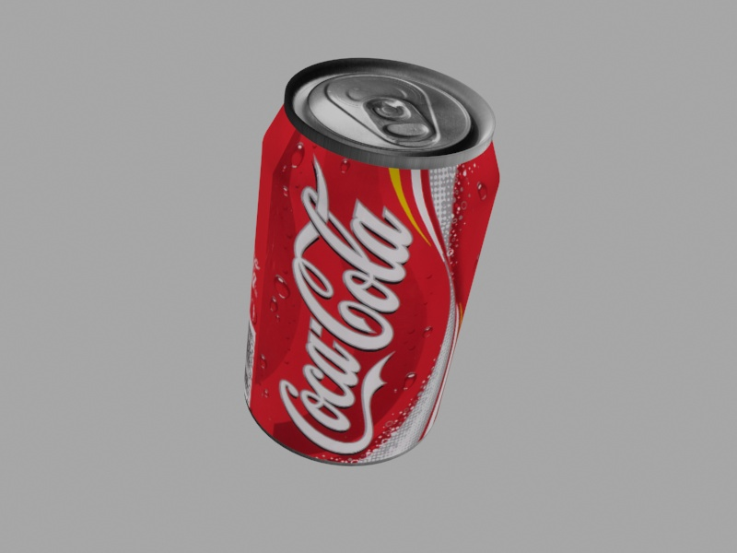

Figure 31: Coca-Cola can modelled in 3ds Max

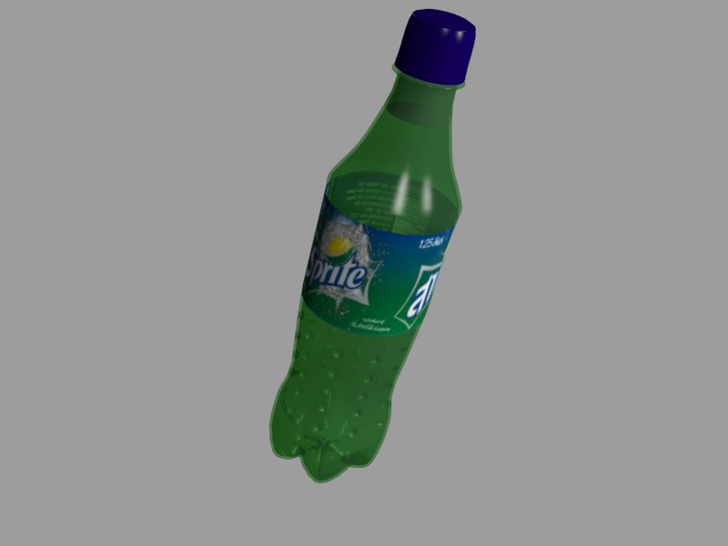

Figure 32: Sprite bottle modelled in 3ds Max

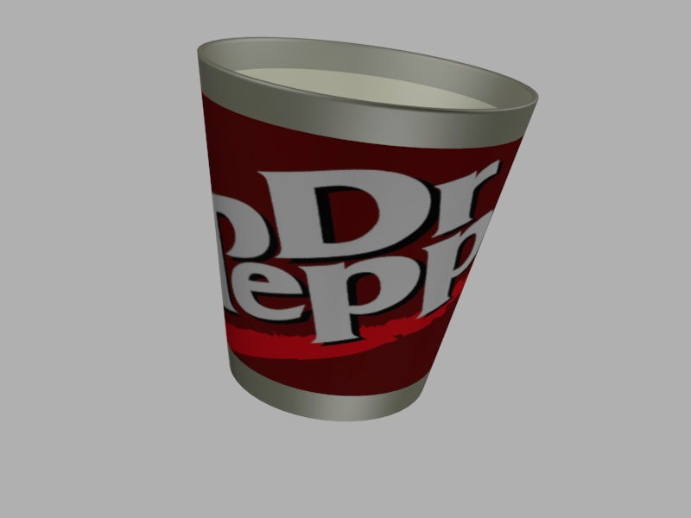

Figure 33: Dr pepper cup modelled in 3ds Max

### Week 3 Results

In week 3 you took your 3ds Max models, added some VRML Helpers and exported to VRML and tested them in a VRML player (e.g. the Cortona3D Viewer or Instant**player**). You then converted the VRML to X3D and tested it also in an X3D player (e.g. the Instant**player**, part of the instant**reality** framework). You then converted both the VRML and X3D files to X3DOM HTML5 and installed (copied) to your public_html directory to test it. You should have results similar to that shown in Figure 34 assuming you spent some time creating a testing template! You can see this result on the **Live Feedback Site**, click on the Coke can image in Laboratory 3 (I haven’t added the Spite of Dr Pepper Cup models).

If you haven’t actually tested your X3DOM based models in an HTML5 template yet, you should make sure they do work, because this lab 4 will focus on creating a responsive mode layout for the 3D content that integrated with your Lab 1 template.

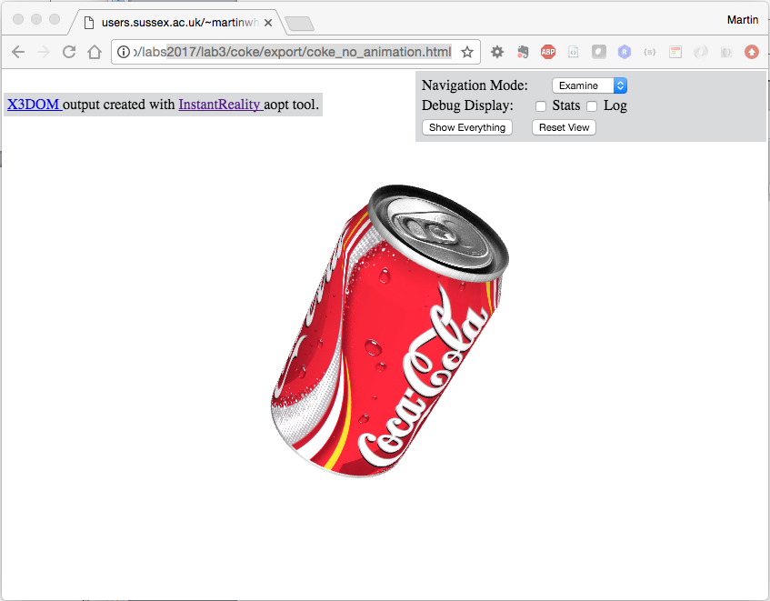

Figure 34: The Coke X3D in HTML5 (i.e. X3DOM) model integrated into an HTML page.

If you used the aopt cmd line tool to convert, you will notice the extra information generated, i.e. the statement on the top LHS and more importantly the tools on the top RHS, which if you examine more closely using Chrome’s Developer Tools illustrate how to insert navigation of the scene, amongst other things.

Remember also that while animation is supported with X3DOM, triggering that animation with a Touch Sensor is not (actually, it might have been implement by now, but best not to use it), for this you will have to modify the X3D code to trigger any animation with JavaScript, e.g. using a button on the web page, or the object itself and the JavaScript onclick() function, for example.

Remember, we showed you the code for this in Lab 3, and you can see how this is done on the <https://doc.x3dom.org/tutorials/models/inline/> where they show you how to include your X3D file inline, or in [Ben’s Kitchen](http://benskitchen.com/x3dom.php) — click on one of the bowls, and then view page source.

It is very useful, and it is expected that you integrate your X3D models inline. Here is the code anyway:

<body>

<script>

function rotateModel() {

if (document.getElementById('modelX3D__myCoke-TIMER').getAttribute('enabled') != 'true')

document.getElementById('modelX3D__myCoke-TIMER').setAttribute('enabled', 'true');

else

document.getElementById('modelX3D__myCoke-TIMER').setAttribute('enabled', 'false');

}

</script>

<x3d>

<scene>

<inline nameSpaceName="modelX3D" mapDEFToID="true" onclick='rotateModel();' url="coke.x3d"> </inline>

</scene>

</x3d>

</body>

The critical part to this code is connecting the nameSpaceName, in this case ‘modelX3D’ to the myCoke-Timer via the double underscore. myCoke-Timer is defined in the <timeSensor> node in the X3D file.

You can also see how to do this in the Week 6 lab tutorial, use Chrome’s Inspect Element to see how we trigger an animation using JavaScript in the Lab 6 Coke can example on the **Live Feedback Site** or navigate to Lab 6 Results, Virtual Museum.

Ok, let’s summarise the skills you have picked up so far:

1. In week 1 you have learnt how to create a fluid grid web page using the Bootstrap 4 framework
   * Set up your site and project files
   * Created the page layout using either a lightweight text editor and other tools and CSS styling with Div tags
   * Added content to the web page
   * Added the main 3D image text
   * Published your web page the Sussex ITS web server, i.e. your public_html/ web space.
   * You must of course already have Sussex web space
2. In week 2 you created relatively simple 3D models using 3ds Max
   * Became familiar with the 3ds Max interface
   * Set up your blueprint and texture map
   * Create 3D models based on spline, lathe and primitive functions to generate the mesh
   * Smoothed the mesh appropriately!
   * Textured your 3D models, i.e. the Coca-Cola can, Sprite bottle and Dr Pepper cup
   * Added some lights and cameras
3. In week 3 you investigated Web3D Formats, particularly X3D and VRML
   * You took your 3ds Max Coca-Cola can model and added some VRML Helpers
   * You then exported the 3ds Max model (with lights and cameras) to VRML
   * You then explored how to render your 3ds Max model with VRML and X3D using a workflow to get from VRML to X3D and then to X3DOM
   * You converted VRML to X3D, X3D to X3DOM, and VRML to X3DOM
   * You then integrated your X3DOM models into a web page in a simple way

We will now bring these skills together to create a basic 3D App that incorporates the essence of lab 1, 2 and 3 results so far.

## Appendix 2 — Plugins for 3D Apps

Figure 35, for example illustrates a basic 3D App (based on a template from the 2014 version of this module) that incorporates week 1, 2 and 3 results using plugins and X3DOM. However, plugins are getting less and less support — Chrome for example doesn’t support plugins like the Cortona3D Viewer anymore. Further, unless you pay for a plugin licence, you get the plugin’s icon floating all over the place.

|  |  |
| --- | --- |
|  |  |
| Home Page | Coke Page: VRML with Cortona3D Viewer |
|  |  |
| Sprite Page: X3D with BS Contact Viewer | Pepper Page: X3D in HTML5 (i.e. X3DOM) |
| Figure 35: Example layout and CSS styling for the basic responsive 3D App using plugins and X3DOM | |

Ok, this Figure 6 template is not very elegant, but those plugin icons spoil the whole thing anyway, further we really would like the plugin to blend better in the web page, e.g. by setting the background colour to match the template within the plugin. This is a design issue. Further, we can’t manipulate (e.g. rotate, animate, …) the 3D model from the HTML DOM (e.g. using the JavaScript onclick() function). With plugins, you generally need a special language interface to communicate between the HTML context and the plugin, which is a complete pain!

To illustrate how much better using X3DOM (or any abstraction over WebGL, e.g. [three.js](https://threejs.org/)) is we can see that in Figure 36, using the same template as Figure 35 we can better blend the 3D with the HTML5. Ok, I already implied the template isn’t going to score well on the design front, but the 3D is written directly into the HTML DOM!

|  |  |
| --- | --- |
| LocalDataHD:engg:eecs:martinwh:Desktop:Screen Shot 2016-02-02 at 12.06.20.png | LocalDataHD:engg:eecs:martinwh:Desktop:Screen Shot 2016-02-02 at 12.06.57.png |
| Home Page | Coke Page: X3DOM |
| LocalDataHD:engg:eecs:martinwh:Desktop:Screen Shot 2016-02-02 at 12.08.04.png | LocalDataHD:engg:eecs:martinwh:Desktop:Screen Shot 2016-02-02 at 12.08.55.png |
| Sprite Page: X3DOM | Pepper Page: X3DOM |
| Figure 36: Example layout and CSS styling for the simple responsive 3D App (2015 version). | |

Needless to say, we won’t use a plugin approach in Lab 4. Instead, we will integrate our 3D models using only X3DOM for Lab 4, which is also a requirement for your assignment. The plugin in dead, long live JavaScript integration!

## Appendix 3 — Steps to Create your Basic 3D App

**Step 1**: Copy your Lab 1 site to your Lab 4 development directory so that you have a good working copy of your Lab 1 site. Make sure this is also working live on /public_html/. You may also be using a localhost on your home machine or laptop if you are not in the lab.

For my setup, I use Dropbox to store my development files so that I can access them from home or the University, and use an SFTP client such as Filezilla to push the site up to the University server. My path variable this year will be:

* dropbox:/3dapp/lab4/

And, I reflect this in my public_html directory:

* public_html:/3dapp/3dapp/lab4/

The public_html path looks odd with two folders the same, but that is because the first /3dapp/ would normally have been /3D_Apps_2020/ as I like to keep a working archive each year, but I am slow;y moving away from thet approach. You don’t have previous years versions to worry about. So you can simly use:

* public_html:/3dapp/lab4/

And, put it wherever you like on your own localhost.

You may recall from lab 1, that I am also using GitHub, but this is optional for you.

Dropbox and GitHub makes my development easier from multiple locations, as I can test on several localhosts and upload to my University ITS web space using filezilla. One small disadvantage over the Dreamweaver CC system is that we have to sync up manually to the server. Dreamweaver, if you use the inbuilt file manager, it detects when you change something and you can simply push changes up to the remote server,

Figure 37 illustrates a screen shot (from 2017) of a local and remote window in FileZilla, it is a simply matter of dragging your files across once set up.

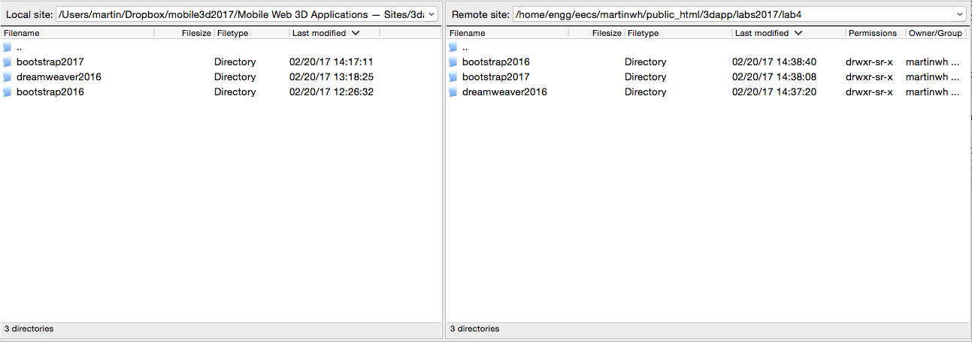

Figure 37: Manually syncing with Filezilla.

Of course, if you just bring your work into the lab where you can simply copy from your Home Share: drive to your public_html sub-folder.

Now that you have your Lab 4 setup you can continue with the next steps, which summarize creating the basic 3D App. I don’t expect the layout indicated in Figure 2 to change, particularly as our Lab 1 is using Bootstrap 4.3.1 and this lab will use either 4.3.1 or Bootstrap 4.4, which will not impact anything much, I hope!

I suggest you try out 4.4 now to see if it impacts anything, if it does stick with 4.3.1. To install simply go to:

<https://getbootstrap.com/docs/4.4/getting-started/download/>

Then download ready-to-use compiled code for **Bootstrap v4.4.1** to easily drop into your project, which includes:

* Compiled and minified CSS bundles
* Compiled and minified JavaScript plugins

I can’t see any immediate problems with Bootstrap 4.4.1, so I change to that for now.

**Step 2**: Make a second copy of the Lab 1 template and rename it coke.html.

**Step 3**: With your coke.html file, replace the main text with a .card class. Remove the Sprite and Dr Pepper .card classes and associated contents. Sort out the CSS to suit.

**Step 4**: Make 2 more copies of the Coke.html file and call them sprite.html and pepper.html, and update the Sprite and Dr Pepper contents from the original files

**Step 5**: Link up your navigation menu. Provide content for the About (use popups) and Contact (use models) and link the Home on each of the Coke.html, sprite.html and pepper.html to the index.html. Then, on the index.html link the dropdown menu for drinks to the appropriate Coke.html, sprite.html and pepper.html, repeating this for each of the drinks html files so that the 4 pages are all linked up. You should now have a simple 4-page 3D App site.

**Step 6**: On each of the coke.html, sprite.html and pepper.html pages we now need to insert your inline X3D code. If you haven’t got inline X3D versions of your 3D models yet, go back to the online conversion tools and create these. Make sure you select the XML encoding (X3D) for the output encoding. You should have three X3D models, e.g. coke.x3d, sprite.x3d, pepper.x3d. The code you need to insert these three models is very simple:

<div id="model3D">

<x3d>

<scene>

<inline url="coke.x3d"> </inline>

</scene>

</x3d>

</div>

We will go through the detail below.

But, you will need to also include the X3DOM libraries, etc. in your HTML5. You should either download the x3dom.css file and install it in your css folder or use the linked release version of the x3dom.js file. However, sometimes, the X3DOM server goes down, so consider [downloading the complete X3DOM package](https://x3dom.org/download/1.3/docs/singlehtml/) and installing it locally into your project so you don’t get caught out later!

For example, here we show the x3dom.css file downloaded and installed in your css folder:

<link rel='stylesheet' type='text/css' href='css/x3dom.css'></link>

But, here we show x3dom.js file uses the x3dom.org CDN:

<script type='text/javascript' src='<http://www.x3dom.org/x3dom/release/x3dom.js>'></script>

Note, you will need both the x3dom.css and the x3dom.js files.

**Step 7**: Test your X3D models in your very simple 3D App, in Lab 4 you should refine this 3D App some more. You should have a result looking something like that shown in Figure 27 using Bootstrap.

## Appendix 4 — Connecting buttons to X3D code via JavaScript in X3DOM

Looking ahead to Lab 6, we will be connecting these buttons to some JavaScript code that will select the required camera view, or start and stop an animation, etc. For now, I give you some code below to think about, feel free to try it out, but we will cover this in more detail in Lab 6.

You already have a selection of buttons created above, the buttons below are just another illustrative example using the <button> tag. It is fairly self-explanatory.

<div id="interaction">

<button type="button" onclick="spin()">SPIN</button>

<button type="button" onclick="wireframe()">WIREFRAME</button>

<button type="button" onclick="lighting()">LIGHTING</button>

<button type="button" onclick="cam1()">FRONT</button>

<button type="button" onclick="cam2()">BACK2</button>

</div>

The JavaScript code that could be connected up to these buttons to create an interactive X3D model is shown below. This is only an example, and it is unlikely you will have prepared your 3D models exactly like this yet, so don’t necessarily expect to connect this particular code up yet. I have given the code here merely to illustrate the picture.

//adapted from example code 'benskitchen.com'

var spinning = true;

var lightOn = true;

function spin()

{

spinning = !spinning;

document.getElementById('model__RotationTimer').setAttribute('enabled', spinning.toString());

}

function wireframe()

{

var e = document.getElementById('model');

e.runtime.togglePoints(true);

e.runtime.togglePoints(true);

}

function lighting()

{

lightOn = !lightOn;

document.getElementById('model__lighting').setAttribute('headlight', lightOn.toString());

}

function cam1()

{

document.getElementById('model__Camera01').setAttribute('bind', 'true');

}

function cam2()

{

document.getElementById('model__Camera02').setAttribute('bind', 'true');

}

In this JavaScript code, you can clearly see that a button has been created, which is linked via the onclick() function to a JavaScript function, e.g. spin, lighting, camera 1, camera, 2, etc. The spin function, for example, first checks the spinning variable, which is set to true. This means, in this case, if your animation is not currently spinning, when you click the button — onclick() — it will be set to spinning, i.e. animation turned on, and so on.